1 | P a g e

Lesson 9: Waves

Overview

Lesson 9 presents an overview of waves in the ocean, including related terminology, physics, and mathematical equations. The lesson defines tsunamis and describes ways that scientists predict and prepare for tsunamis. In the activity, students apply the equations they have learned to predict when tsunamis triggered by earthquakes at given depths will affect specified locations.

Lesson Objectives

Students will:
- Define a wave and the terminology commonly used to describe the anatomy and movement of a wave

- Differentiate shallow and deepwater waves

- Predict when tsunamis originating at specified locations will affect nearby areas

Lesson Contents

- Teaching Lesson 9
  - Introduction
  - Lecture Notes
  - Additional Resources

- Teacher’s Edition: Can You Outrun the Tsunami?

- Student Activity: Can You Outrun the Tsunami?

- Student Handout

- Mock Bowl Quiz
Standards Addressed

National Science Education Standards, Grades 9-12
Physical science
Earth and space science Science in personal and social perspectives

Ocean Literacy Principles
The ocean and humans
are inextricably interconnected

DCPS, High School
Environmental Science
E.4.7. Investigate and identify the causes and
effects of severe weather

Physics
P.6.1. Explain that waves carry energy from one place to another
P.7.12. Describe waves in
terms of their fundamental characteristics of speed, v; wavelength, λ; frequency, f; or period, T, and amplitude, A, and the relationships among them. For example, fλ
= v, f = 1/T. Solve problems involving wavelength, frequency, and wave speed

Lesson Outline1

Introduction
Introduce the lesson by showing the video named “Animation of September 29, 2009 tsunami” at the link below:

http://www.noaa.gov/features/03_protecting/tsunamiaware.html

NOTE: You will need QuickTime to play this video.

This is a NOAA video that shows an animation of a tsunami strike in 2009. Tell your students that waves transmit energy through matter. Large waves like tsunamis unleash quite a lot of energy when they strike land. Understanding the ways in which waves work can help scientists prepare for disastrous tsunamis and prevent people from being harmed or killed.

Lecture Notes
Use the PowerPoint for Lesson 9 to present (File: Lesson 9 – Waves.ppt) to present the following information. Distribute the Student Handout before you begin for students to
take notes on key information.

A wave is transmission of energy through matter (slide 5)
  - As energy travels through matter, the energy is transmitted to adjacent matter.

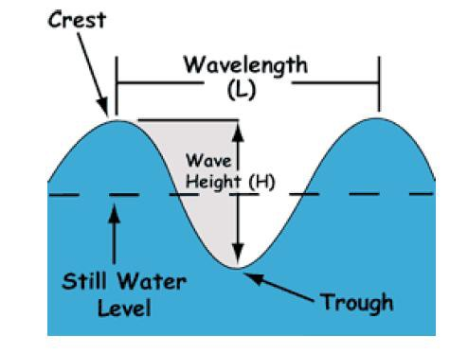
  - As energy moves through matter, the matter moves and then returns to its original position.

Some important features of a wave (slide 6)
- The major parts of a wave are the crest (the highest point), the
trough (the lowest point), the height (distance from trough to crest), the wavelength (distance between identical points on two
waves, typically crest to crest) and period (the time it takes for
the same spot on two
consecutive waves to pass the same point)2.

- Unless otherwise indicated, all websites provided or referenced were last accessed in November, 2010.
- Photo: Navy, http://www.onr.navy.mil/Focus/ocean/motion/waves1.htm

- The ratio of a wave’s height to wavelength (H:L ratio) can tell us some information about the wave, for example if it is about to break.

There is more than one type of wave (slide 7)
- Two major wave types to know are shallow-water waves and deepwater waves.

- These waves are defined by their wavelength compared to the depth of the water in which they occur. A deepwater wave occurs when water depth is greater than or equal to 1/2 of its wavelength. A shallow-water wave occurs when water depth is less than or equal to 1/20 of its wavelength.

Note: If you have time, you may want to describe and demonstrate another type of wave known as an internal wave. If you make the water bottle described below ahead of time, it shouldn’t take longer than a few minutes to show the students how it works and pass it around as you describe internal waves.

An internal wave can occur within different density layers of the ocean or atmosphere. The students should be familiar by now with the way that the ocean forms layers. Scientists still have much to learn about internal waves, but they think internal waves in the ocean may get their energy from tides and storms. To show students how this works, fill a clear plastic soda bottle halfway with colored water and halfway with oil. These two liquids have slightly different densities. As you rock the bottle back and forth, you should see waves form between the oil and water layers.

How does a wave break? (slide 10)
- As waves move from deep water to shallow water, they come into contact with the ocean floor. This causes the wavelength to decrease and wave height to increase.

- Once the H:L ration surpasses 1:7, the wave breaks.

Why is it important to know so many details about waves? (slide 11)
- Waves, especially tsunamis, can be very destructive.

- A tsunami is a shallow-water wave triggered by displacement of a large amount of water

- Understanding wave physics has helped scientists learn how to identify disturbances that can trigger tsunamis and predict when associated waves will reach affected locations.

Additional Resources
  - Background information: http://wcatwc.arh.noaa.gov/about/physics.htm

Can You Outrun the Tsunami?

Overview
This activity is adapted from the “NOVA: Wave That Shook the World” Classroom Activity.
©WGBH Educational Foundation. Used with permission. www.pbs.org/wgbh/nova/.

In this activity, students are presented with a scenario of an Earthquake triggering a tsunami at a particular point on Earth. Students calculate the time it will take for the tsunami to reach specified locations.

Background
Knowing information about wave physics can save lives. You may have seen videos of the terrible destructive power of tsunamis. These shallow-water waves happen when large amounts of water are displaced, for example by earthquakes, icebergs falling into the ocean or even a volcanic eruption. When scientists detect these disturbances, they can figure out how fast the tsunami is traveling, where it will hit and when. In this way, they can do their best to evacuate people before the tsunami hits and save lives.

In this activity, students play the role of scientists working for NOAA that have received information about a disturbance in the ocean. Unfortunately, the high-tech computing systems have shut down. Students have to use mathematical relationships to determine how long it will take the tsunami to reach given locations.

Procedure
- Divide your class into groups of 4-5 students per group. Distribute the Student Activity.

- Students will have to convert numbers to different units in this exercise. You may want to help students with the conversions by running through an example of m/s to km/h conversation before the activity:
Convert 100m/s to km/hr:
100m/s * (1m/1,000km) * (60s/1min) * (60min/1hr) = 360km/hr

- Students will read the Tsunami Scenario and identify the given location on a map.

- Students will use the wave speed formula below to calculate the speed at which the tsunami is traveling. Speed of the tsunami (meters/second) is equal to the square root of g (the acceleration due to gravity, which a constant 9.81 meters/second) times the water depth (d) at which the disturbance occurred (meters).

Wave Speed Formula
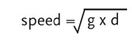

NOTE: You may also see reference to tsunami “velocity” (V) at the bowl. Velocity refers to the rate and direction of water displacement but, for our purposes, can be thought of as similar to speed.

- Students should convert their final answer to km/h: 1km = 1,000m
1hr = 60 minutes

- Finally, students fill out the information sheet that will be passed on to emergency services personnel to help warn and aid people in the affected areas.

Calculating Time to Affected Locations
The website listed in this section allows students to enter lat and long information for two locations, and it will calculate the distance between them (km). The students can use this site to find the distance between the epicenter and each affected location. You can have them Google each location to find lat/long information themselves, or you may provide
them with this information if you want to save time.

Tsunami Scenario
Students are told they have received information that there was an earthquake in Seward, Alaska large enough to produce a tsunami at an ocean depth of 4,000m. Calculate the speed of the tsunami at this depth. Then, calculate the time it will take the tsunami to reach the two following affected locations:
- Kodiak, Alaska
- Kauai Island, Hawaii

They should record their data and answer the questions on the information sheet.

Answer Key
- Speed of the tsunami:

S = sqrt(9.81m/s2 * 4,000m) S = sqrt(39,240m2/s2)
S = 198m/s

(198m/s) * (1km/1,000m) * (60s/1min) * (60min/1hr) = 713km/h

- Time that it will take to reach each location: Kodiak, Alaska: about 32 minutes Kauai Island, Hawaii: about 6 hours

- List the locations in the order in which the tsunami will strike in the table below. Indicate some actions at each location that should be taken to help local citizens.
Order | Affected location  (include coordinates) | Time until  tsunami hits | Emergency actions
1st | Kodiak, Alaska | 32min | Emergency actions for each will vary, and may include evacuating coastal residents,  alerting local hospitals, sending in emergency supplies from outside the area  if there is time, etc.
2nd | Kauai Island, Hawaii | 6hr

Can You Outrun the Tsunami?

Introduction
Knowing information about wave physics can save lives. You may have seen videos of the terrible destructive power of tsunamis. These shallow-water waves happen when large
amounts of water are displaced, for example by earthquakes, icebergs falling into the ocean or even a volcanic eruption. When scientists detect these disturbances, they can figure out how fast the tsunami is traveling, where it will hit and when. In this way, they can do their best to evacuate people before the tsunami hits and save lives. Today, that is your job!

You and your team members are scientists working for NOAA and you have received information about a disturbance in the ocean. Unfortunately, all your high-tech computing systems have shut down. How are you going to figure out where and when the tsunami will strike?

Procedure
For this activity, you will be given a scenario of the location of disturbance (i.e., the origin or epicenter of the tsunami) you detected and the depth at which it occurred. You will use
this information to calculate the speed of the tsunami and when it will affect given locations.
- Read the Tsunami Scenario and identify the location on a map.

- Use the wave speed formula below to calculate the speed at which the tsunami is traveling.

- Fill out the information sheet that will be passed on to emergency services personnel to help warn and aid people in the affected areas.

Wave Speed Formula

Speed of the tsunami (meters/second) is equal to the square root of g (the acceleration due to gravity, which a constant 9.81 meters/second) times the water depth (d) at which the disturbance occurred (meters).

NOTE: You may also see reference to tsunami “velocity” (V) at the bowl. Velocity refers to the rate and direction of water displacement but, for our purposes, can be thought of as similar to speed.

Convert your final answer to km/h: 1km = 1,000m
1hr = 60 min
1 min = 60 sec

Calculating Time to Affected Locations
To figure out how long it will take for the tsunami to reach the affected locations, first calculate the distance in meters between the epicenter and the affected location. Use Google to find the coordinates (latitude and longitude) of the epicenter and each location. Enter the information for the epicenter and location at the website below to find the distance between them in km and multiply by 1,000 convert to meters.

http://www.chemical-ecology.net/java/lat-long.htm

Once you know the distance, multiply by the speed of the tsunami to find out how long you have before the tsunami strikes.

Distance (meters)/Speed (m/second) = time until tsunami (seconds) State your final answer in hours, minutes and seconds.

Tsunami Scenario
You received information that there was an earthquake in Seward, Alaska large enough to produce a tsunami at an ocean depth of 4,000m. Calculate the speed of the tsunami at this
depth. Then, calculate the time it will take the tsunami to reach the two following affected
locations:
- Kodiak, Alaska
- Kauai Island, Hawaii

Record your data and answer the questions on the information sheet.

Tsunami Information Sheet

Epicenter: Seward, Alaska

- Speed of the tsunami:

- Time that it will take to reach each location: Kodiak, Alaska:

Kauai Island, Hawaii:

- List the locations in the order in which the tsunami will strike in the table below. Indicate some actions at each location that should be taken to help local citizens.

Order of tsunami  strike | Affected location (include  coordinates) | Time until tsunami  hits | Emergency actions
1st
2nd

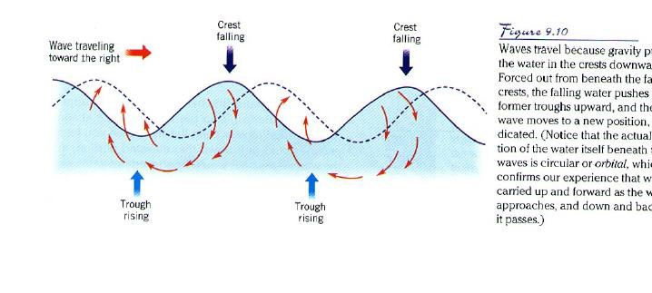
shown in the diagram below3

Tips for the Bowl - Waves

The information on this handout is based on previous NOSB questions and topics. Look over these concepts to bring your best to the competition!

Important Terms
Below are important terms you need to know for the Bowl. Write down definitions during your teacher’s presentation. Definitions for important terms that may not have been included in the presentation are provided for you.
Crest:
Trough: Period (T):
Wavelength (L): Deepwater wave: Shallow-water wave:
Fetch: The distance that wind blows over water Duration: The length of a wind gust over water

NOTE: The size of a wind-driven wave depends in part on fetch and duration.

Orbital motion – This is the circular movement of water as energy is transmitted through,

Remember these formulas!!
1. Wave speed =L/T 2. Tsunami speed = sq root (g*d)(g=acceleration due to gravity, a constant 9.81 meters/second; d=depth of origin of disturbance)

- Photo: Navy, www.onr.navy.mil/Focus/ocean waves1.htm; Note that this website also contains helpful information on orbital motion.

Waves

  - Short answer: This term refers to the time it takes identical points on two waves to pass through the same point.

Answer: Period

  - The lowest point on a wave is the:
    - Crest
    - Wavelength

y. Trough
z. Benthic

  - Wavelength is best described as the:
w. Vertical distance between a wave’s crest and the next trough

x. Horizontal distance, either between the crests or troughs of two consecutive waves.
- The number of waves that pass a given point in a designated amount of time
- The distance a wave travels in one second

  - If you followed a single drop of water during a passing wave, it would:
- Move horizontally
- Remain stationary
- Move away from shore

Move in a circle

  - Deep water waves are defined as waves found in water deeper than:

w. 1/2 their wavelength
- 1/3 their wavelength
- 2 times their wavelength
- 4 times their wavelength

  - Shallow water waves are defined as waves in water shallower than:
w. 1/2 their wavelength

x. 1/20 their wavelength
- 2 times their wavelength
- 2/3 their wavelength

  - A wave has a speed of 10m/s and a period of 5s. What is the wavelength of this wave?
- 2m
- 5m
- 10m

z. 50m (speed= wavelength/period)

  - Which of the following is true of a tsunami?
- A tsunami is a deep water wave
- A tsunami may be caused by the tides, and thus is sometimes accurately called a tidal wave
- The speed of a tsunami can be calculated by dividing its depth(d) by the
acceleration due to gravity (g)

z. A tsunami is caused by displacement of large volumes of water, for example during an earthquake

  - Short answer: This term refers to the highest point on a wave.

Answer: Crest

  - Team challenge question

A

B

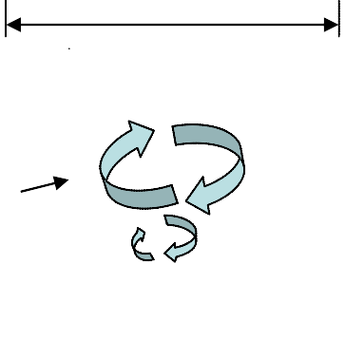
- Label letters A and B on the wave diagram. (2pt)

- This wave has a wavelength of 100m at a depth of 4m. Is this a deepwater or shallow-water wave? How can you tell? (4pt)

- As this wave moves toward the shore, will the wavelength increase or decrease?
What about the wave height? (2pt)

- At what H:L ratio will the wave break? (1pt)

ANSWER

A

B

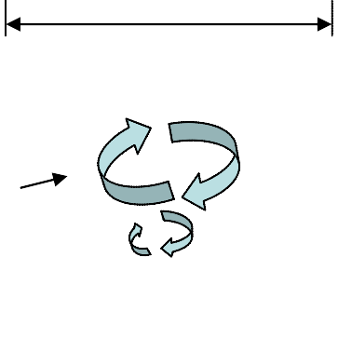
  - Label letters A and B on the wave diagram (2pt)

A: wavelength (1pt)
B: orbital wave (1pt) or orbital motion of a particle

  - This wave has a wavelength of 100m at a depth of 4m. Is this a deepwater or shallow water wave? How can you tell? (4pt)

Shallow-water (2pt) because the depth is less than 1/20th of the wavelength (2pt)

  - As this wave moves toward the shore, will the wavelength increase or decrease?
What about the wave height? (2pt)

Wavelength will decrease (1pt) and wave height will increase (1pt)

  - At what H:L ratio will the wave break? (1pt)

H:L ratio exceeding 1:7

