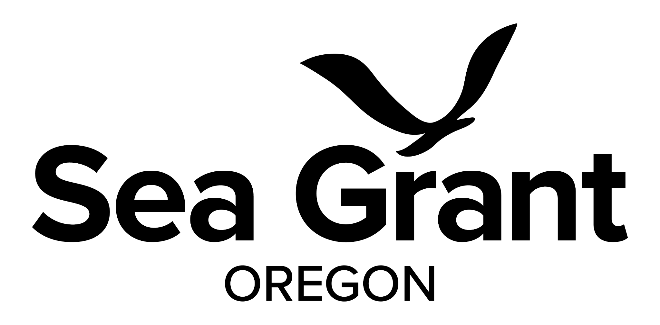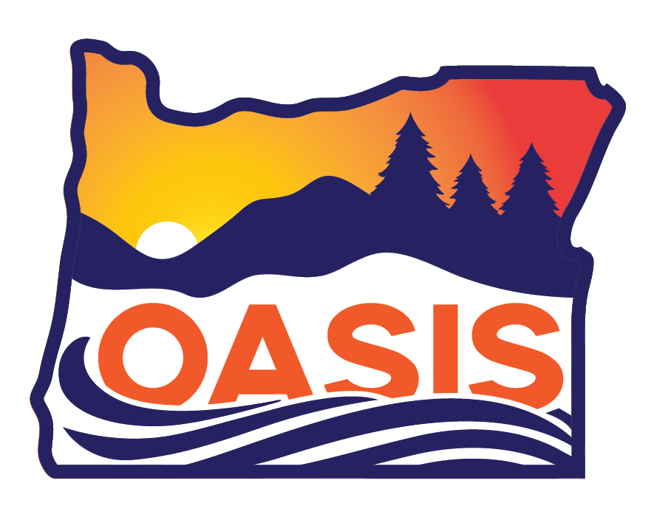

Oregon Applied Sustainability Internships (OASIS) Program

2026 Host Business Application
Thank you for your interest in the OASIS program! Oregon Sea Grant (ORSG) and Oregon Department of Environmental Quality (DEQ) administer the OASIS program through an Environmental Protection Agency (EPA) Pollution Prevention (P2) grant. This paid, 11 week internship program runs from June 15th to August 28th, 2026 and recruits 3rd and 4th year undergraduate and graduate level students to conduct research that helps Oregon businesses reach their waste prevention and sustainability goals. Since 2017, over 45 businesses have hosted OASIS interns, a win-win program that supports environmental workforce development, waste reduction, environmental protection and economic savings. This is a voluntary program that is not intended to satisfy regulatory or permit requirements; rather, it assists businesses in reaching their sustainability and environmental goals beyond permit compliance.
Per our EPA P2 Grant requirements, businesses identified in the P2 National Emphasis Areas described below are given priority placement:
- Food and beverage manufacturing (NAICS 311 and 3121)
- Chemical manufacturing, processing and formulation (NAICS 325 and 4-6 NAICS codes under 325)
- Aerospace products and parts manufacturing (NAICS 3364)
- Metal manufacturing and fabrication (NAICS 331 and 332)

Other priorities for the program include:
- Businesses located on the coast
- Small or medium sized businesses
- B corp certified businesses
Applications will be reviewed upon receipt and companies will be contacted by OASIS staff as soon as possible for additional project development and scoping, if needed.
For additional information, frequently asked questions, Success Stories highlighting project solutions and business savings, and more, please visit the OASIS website.
Application Deadline: February 15, 2026. Early applications are encouraged.
If you have questions about the program, or need additional time with the application, please reach out to our team:
- Blaine Schoolfield, Undergraduate Program Coordinator, Oregon Sea Grant; blaine.schoolfield@oregonstate.edu, 541-737-8410 (program administration)
- Lisa Cox, Senior Toxic Reduction Analyst, Oregon Dept. of Environmental Quality; lisa.cox@deq.oregon.gov, 503-863-4797 (technical assistance, host business project development)
- Sarah Kolesar, Associate Director, Oregon Sea Grant Research and Scholars; sarah.kolesar@oregonstate.edu, 541-737-8695 (program administration)
Project Requirements:
- Clear toxic use and/or waste/energy prevention potential with measurable project goals (measurable results include: time and money saved, environmental impacts prevented through kilowatt hours reduction, emissions prevented, etc.).
- Project focuses on prevention and waste reduction, not recycling.
- Project tasks, goals and outcomes are clearly identified in application, and project completion is possible in 11 weeks (or ~ 400 hours).
- Project is not designed around complying with environmental permits (goal is to think beyond permit requirements).
- Designated host capable of supporting student’s work and providing a quality and safe work site; including culturally-responsive mentoring.
- Project results (lessons learned, processes) are transferable to other businesses or similar sectors.
- Host businesses are expected to provide in-kind cost share to help meet requirements of the federal EPA award, and are asked to consider additional contributions to support the OASIS program.

What is expected of the host business?
- Mentoring and Project Management:
  - Attendance at a preliminary meeting with OASIS representatives to review project and scope of work for final acceptance.
  - Attendance at a virtual host business orientation in Spring, 2026 (required) and the opportunity to access mentorship training materials offered through our national partners (optional).
  - Commitment to selecting an intern from up to three candidates, pre-screened by OASIS, ensuring equal consideration for all applicants in the interview process.
  - Participation in intern orientation (optional) and attendance at final presentation sessions - one internal and one public facing (required).
  - Provide interns with an orientation, including safety protocols and access to Title IX or similar resources, as appropriate for your business.
  - Set expectations for the summer with your intern and discuss these expectations with OASIS staff.
  - The host business is responsible for overseeing the intern’s daily work and providing assistance to enable the intern to accomplish tasks.
  - Provide interns with appropriate supervision and mentorship, including regularly-scheduled check-ins (at least weekly) and participation in bi-weekly team meetings throughout the 11 week internship.
  - Flexibility so that interns may participate in occasional OASIS trainings and events.
  - Provide resources and support for students from various backgrounds, including reasonable accommodations for different abilities.
  - Monitor and encourage intern progress, offer learning opportunities, provide regular and constructive feedback to the intern on performance, and work with the intern to develop strategies to overcome workplace challenges.
  - Supply interns the tools necessary to conduct their work (desk, computer, safety equipment, transportation to off-site meetings, etc.). Any travel required to complete project-related work should be covered by the host.

- Outreach and Communication:
  - Communicate with Oregon Sea Grant in a timely manner, as needed, to ensure intern learning and success.
  - Review and approve intern materials and final deliverables including: science communication posts (LinkedIn), final report, final presentations (internal and public facing), P2 table, etc.
  - Ability to release environmental and economic savings results in a “Success Story” that will be posted on the public facing OASIS website.
- Cost Share and Matching Funds:
  - Ability to submit in-kind matching funds at the end of the internship (calculated in staff hours, office space, travel reimbursement, etc. See section on “Matching Funds” below for details).

What is expected of the intern?
- Professional conduct in line with host organization procedures and norms.
- An open-minded, respectful approach conducive to teamwork.
- A primary focus of time and effort towards success of the assigned project.
- Dedicate approximately 40 hours/week to project duties and tasks, program trainings, and other related activities.
- Participation in all mandatory intern program activities (orientation, expectations meeting with host, OASIS trainings, and final symposium) and completion of all requirements (science communication, portfolio, etc.).
- Communicate with host and Oregon Sea Grant regularly to ensure learning, host satisfaction, and success.
Host selection criteria:
Host business applications will be accepted based on the degree to which the host business can present a well-developed project that is likely to be completed, or reach a significant milestone, in 11 weeks. Hosts should provide their intern with the necessary tools for the proposed work and provide meaningful training and professional development experiences for their intern. Other positive attributes for applications are alignment with Oregon Sea Grant’s mission, existing or potential partnerships with Oregon Sea Grant / Oregon State University, and willingness to create a supportive environment for all interns.
Housing is often a barrier for interns, so please consider the availability of affordable housing (~$1,300 for the 11 week period) in your location. While not all host applications will be selected, applications that can provide housing or demonstrate that affordable housing is available are more likely to be successful.
Insurance: OASIS does not provide insurance to interns. Do you require that summer interns have liability, workers’ compensation, or other insurance coverage? Your organization may hire a student as an employee, and they can still be considered an Oregon Sea Grant intern. Please specify this need as soon as possible. If you do not know the answer to this question, contact your Human Resources department. For more information, please contact Lisa Cox at (503) 863-4797 or lisa.cox@deq.oregon.gov or Blaine Schoolfield at (541)737-8410 or blaine.schoolfield@oregonstate.edu.
Next steps and available resources:
Once accepted as a host, OASIS program personnel will advertise your position and screen all intern applications for suitable candidates. ORSG will select up to three pre-screened candidates for the host to interview. The host business is responsible for selecting the candidate they deem the best fit and is responsible for conducting any additional tests or training required for the intern to work on site (i.e. drug testing, background checks, etc.). Intern applications open in late March with finalized placement occurring in May.

We can provide you with examples of previous project descriptions, deliverables, outcomes, and success stories. The OASIS program has mentorship resources for hosts, we can help establish internship expectations, and will provide scholars with training in pollution prevention and professional development, supporting your mutual success along the way. Detailed program information and a general program timeline is available in the comprehensive OASIS handbook from 2025. An updated handbook will be available in early 2026.

Please fill out all application fields on the following pages and contact us with any questions (we are here to help!).

Oregon Applied Sustainability Internships Program

2026 Application Form

Please complete this section and return the application, as a Word document, to blaine.schoolfield@oregonstate.edu by Tuesday, February 10, 2026

Business Name: Click here to enter text.
Business NAICS or SIC: Click here to enter text.
Name of Business Mentor and Secondary Mentor(s): Click here to enter text.
Phone number for Mentor and Secondary Mentor(s): Click here to enter text.
Email for Mentor and Secondary Mentor(s): Click here to enter text.
Worksite Address: Click here to enter text.
What are this facility’s products or services? Click here to enter text.
Number of employees: Click here to enter text.
How did you hear about OASIS? Click here to enter text.

OASIS Project and Training –

Describe the proposed projects, primary and secondary (or more). The best projects will be measurable, look upstream to prevent or reduce waste and/or toxic chemical usage, produce results that we can share (except confidential business information) and clearly identify the relationship to environmental improvement.
Click here to enter text.
What processes will the student need to research and/or investigate?
Click here to enter text.
Please describe your ideas for the intern's role and responsibilities. Include tasks and activities you expect the intern to perform in order to meet the project's goals.
Click here to enter text.
How will the project's completion meet your environmental initiatives or goals? What improvements would you like to see in your facility?
Click here to enter text.
Are there specific skills and abilities you believe the intern should possess to make this project a success?
Click here to enter text.
Who would supervise the intern? Please provide name, title, and email if different from mentors listed above.
Click here to enter text.
Please describe the level of technical support your facility can provide an intern. Include the supervisor's technical abilities, time availability, and any subcontractors that may play a role in the project.
Click here to enter text.
Whose approval would be needed to implement intern suggestions? (Name, title, and email)
Click here to enter text.
Please describe the safety training you will provide the intern at the start of the student's internship. Include information about the safety topics that will be addressed and how the intern's understanding will be assessed. Is there any required PPE (e.g. steel-toed safety shoes)? Will the company reimburse the student for required PPE?
Click here to enter text.
Please indicate preferred majors for your intern (Engineering, Food Science, Environmental Science, Sustainability, etc.).
Click here to enter text.
Does your company have any restrictions on the ability to provide certain accommodations, for example service animals?
Click here to enter text.
Do you approve of OASIS using your company name in student advertising/recruiting to fill the internship?
Click here to enter text.
Additional Details
In response to a combination of feedback from former interns and questions asked during the interview process by applicants, we request the following information. Please provide answers to these questions to the best of your ability.
Former interns expressed an interest in learning more about their host business at the start of their projects. Please share some ways you might be able to orient and expose your intern to your business, worksite, co-workers, and additional aspects of your organization apart from opportunities related to their specific project(s)?
Click here to enter text.
What is the approximate breakdown of the amount of time your intern will spend in the office, field or virtually?
Click here to enter text.

Do you anticipate travel (away from your business location) will be necessary for your intern? Will there be overnight travel? What is the approximate proportion of time your intern will be traveling?
Click here to enter text.
What are the typical work hours for your intern? Do you allow telework and, if so, how many days a week do you anticipate telework/in person hours? Do you anticipate any early mornings, late nights, and/or weekend work?
Click here to enter text.
Is a car and/or driver’s license an absolute requirement for this position? If yes, please describe why.
Click here to enter text.
Is this position restricted to U.S. citizens only, or can your business accept international students? Are there any other restrictions for students selected for this position (such as an enrollment requirement)?
Click here to enter text.
Matching Funds
Required Cost Share for OASIS Hosts
The EPA grant that supports the OASIS program requires matching funds, typically in the form of in-kind support from Oregon Sea Grant, our partners, and hosts. Typical sources of host support include in-kind staff hours dedicated to intern mentoring, use of office space and other facilities, travel reimbursement, equipment costs, etc. All OASIS hosts are asked to contribute some level of in-kind support; annual match totals will be reported through data collected in third-party matching forms to Oregon State University (the home institution of Oregon Sea Grant). Individual match-form data is neither reported to, nor accessible by, the EPA. You can view an example match form here.
To break down the costs of the OASIS internship, each intern is provided with a stipend for living expenses and hosted activities throughout the summer, while housing expenses are not typically provided. The total direct 2026 stipend cost for each intern is $6,800 while overall costs per intern exceed $10,000. These additional costs include administrative staff time; expenses associated with hosting events such as trainings, orientation and the final symposium; supporting intern travel to attend these events or other professional meetings; and purchasing / maintaining shared equipment for intern use. While not required, cost sharing at least 50% of direct stipend costs (i.e. $3400) is requested for all host businesses. Returning businesses are asked to contribute additional cost share as in-kind or even direct financial support (see below for more details).
In practice, the cost savings and operational benefits identified by OASIS interns often far exceed the suggested cost-share amount. We understand that providing a cash match is not feasible for all organizations, and we strongly encourage you to apply as an OASIS host regardless of your ability to offer direct financial support. Meaningful participation in OASIS comes in many forms, and we value the expertise, mentorship, and learning opportunities that hosts provide to our interns.
What amount does your organization anticipate providing in cost share?
Click here to enter text.
How can your business’s cost share be applied (e.g. contract with Oregon Sea Grant, stipend payment, reimburse intern expenses such as travel or housing, in-kind, direct bill to an OSU index, etc.)?
Click here to enter text.
How to contribute to the OASIS program:
Can your organization make a charitable donation? The ORSG Summer Interns Program is listed on the Agricultural Research Foundation (ARF) Donate page. Payments can be made directly with PayPal, or by invoice, and will be applied to stipends, travel, or equipment.
Can you make direct payments to the intern ? One way to offset expenses is to directly reimburse the intern. If possible, payments to individuals are a good option for work travel related charges. Note that some businesses in remote locations have covered lodging expenses during a student’s internship as another way to provide support. Please let us know if you offset an intern’s expenses in these ways.
Are you able to set up a contract with OSU? Oregon Sea Grant can receive funds through Oregon State University via a contract agreement. Note that 100% of funds will be applied to intern expenses (indirect charges are not required for stipend payments). Funds that are already at the university can be applied to intern expenses by directly billing an index.
Questions?
Contact Blaine Schoolfield, ORSG Undergraduate Program Coordinator, at blaine.schoolfield@oregonstate.edu or 541-737-8410 or Lisa Cox, Oregon DEQ Senior Toxic Reduction Analyst at lisa.cox@deq.oregon.gov or 503-863-4797.
Please reach out if you would like to talk through the application, we are happy to work with you.

