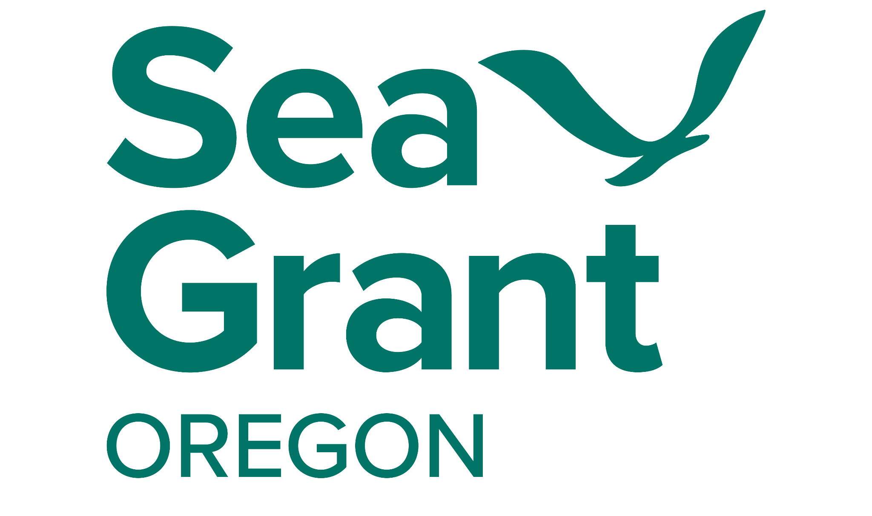
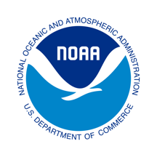
Oregon Sea Grant

Program Development Proposals

Proposals reviewed quarterly, due: December 31, March 31, June 30, and September 30, before 5:00 p.m. PST
Individual requests for rapid response or event support outside of planned review periods may also be considered.
Individual requests typically do not exceed $10,000
Larger requests are occasionally considered and are subject to peer review and approval by the National Sea Grant Office
Project Duration: One year or less

Purpose
In addition to competitive grants awarded on a two-year cycle, Oregon Sea Grant offers modest grants for project opportunities or special circumstances, when resources are available. These projects typically arise between the regular application periods and must align with the Oregon Sea Grant strategic plan. These funds generally are not intended to supplement an existing project, but to provide seed money for exploratory or high-risk/impact efforts, or to respond to urgent needs or unforeseen opportunities that require a timely effort. Oregon Sea Grant also considers requests for event support (or total requests less than $2,500) through our Conference and Activity Support program (see the Oregon Sea Grant “Conference and Activity Support Policy” for details).

Timing
Program development proposals will be considered on a quarterly basis. Requests should be submitted no later than December 31, March 31, June 30, or September 30 for planned reviews in January, April, July, and October, respectively. Decisions are communicated typically within 6-8 weeks of the relevant quarterly deadline. Individual requests for rapid response outside of planned review periods may also be considered. Please contact the Oregon Sea Grant Director for details.

Funding
Program Development grants are modest (total awards typically do not exceed $10,000) and should be one year or less. Larger requests are occasionally considered and are subject to peer review and approval by the National Sea Grant Office. Given our limited funding, success of requests for more than $10,000 (total award) will be lower. Cost-share is not required for program development proposals, however, opportunities for leveraged funds and cost-sharing are welcome. Please contact us to discuss possible cost share for your project. Grant funding comes from our NOAA appropriation. Funding levels are subject to change and rescission based on Congressional actions.

Process
Contact the ORSG Director to discuss your proposed project ideas before submitting a Program Development proposal. We strongly encourage you to familiarize yourself with Oregon Sea Grant’s strategic plan, as well as currently funded research projects and other strategic investments, to inform the development of your proposal concept. These are available on our website. How your proposed project may contribute to the breadth of Oregon Sea Grant programming is a consideration during review. After you have discussed the proposed project with the ORSG Director and received approval for the submission, email eseagrant@oregonstate.edu at least a week prior to proposal submission to register for eSeaGrant (this step is required even if you already have an eSeaGrant account).

We use eSeaGrant, a web-based tool for submitting, reviewing, updating, and tracking program development proposals and projects. If you cannot submit your proposal using the eSeaGrant system, please contact the Oregon Sea Grant program for accommodation.

Proposal Submission Summary:
- Contact the Oregon Sea Grant Director to discuss your proposal.
- Submit your proposal through eSeaGrant by the quarterly review deadline.
- Decisions will be communicated within six to eight weeks of the relevant quarterly deadline.
- Projects recommended for funding are expected to complete the National Environmental Policy Act (NEPA) Abbreviated Environmental Compliance Questionnaire and submit assurance of all required permits or permit applications prior to undergoing NEPA review.

Eligibility
Proposals may be submitted by faculty of any public or private institution of higher education in Oregon; the project’s lead Principal Investigator (PI) must be deemed eligible by their institution to receive extramural funding. While non-academic investigators may be included among the co-principal investigators (co-PIs), awards will typically be made only through colleges and universities. Any special eligibility criteria will be published on the Oregon Sea Grant Program Development website.

For all program development awards, we encourage the involvement of collaborators and investigators who are not Oregon university faculty (collaborators may be with industry, state/regional/federal agencies, Tribes, NGOs, and/or other research or academic institutions).
- Direct salary support for individuals from state and federal agencies, tribal governments, for-profit or foreign organizations is not allowed; however, non-federal contributions can be counted as matching or in-kind support for the project.
- Project participants who are employees of Sea Grant may be part of a project team or serve as the lead Principal Investigator.
- Project budgets for Sea Grant employees should follow Oregon Sea Grant’s internal policy on additional support for partially-core funded employees.
- Oregon Sea Grant encourages submissions from investigators new to Sea Grant and from a variety of disciplines and experiences. We encourage and welcome all applicants to apply for this opportunity.
- If we need additional details, we will contact you.

Student-led projects are also accepted. While funding for all awards over $10,000 (total costs) will be made to a designated faculty member (typically the major advisor), graduate students are encouraged to lead the development and submission of proposals for discrete projects aligned with ORSG’s strategic plan.

Information required for the proposal in eSeaGrant includes the following:
- Executive Summary (optional) is requested to facilitate program review. An optional 250-300 word summary describing the objectives, methodology, and rationale for the project, including expected project outcomes is requested.
- Programmatic Alignment (required) You must identify how your proposed work aligns with the Oregon Sea Grant Vision, Mission, Values, and/or our focus areas as described in the ORSG Strategic Plan.
- Program Development Proposal Narrative following the format outlined below. This will be uploaded as an attachment in eSeaGrant (PDF file). We need clear but brief answers to the questions posed in the outline, which correspond to the review criteria listed below. This guidance is also provided in eSeaGrant.
- Budget and Budget Justification following the format provided in eSeaGrant. Instructions are provided in the eSeaGrant system.
- Data Management Plan following the template provided in eSeaGrant, this document will be uploaded as an attachment in eSeaGrant (PDF file).
- Potential Peer Reviewers (if required). Suggest at least two potential peer reviewers (more for higher funding requests), avoiding potential conflicts of interest. Our Conflict of Interest Policy is available in eSeaGrant.

General proposal guidelines
Your proposal, based on the outline below, should be two to five pages (12-point type,
single-spaced, not including figures and references). Your budget will be a separate attachment and should be completed using the ORSG budget form in eSeaGrant. Please provide clear but brief answers to the questions posed in the outline and explicitly address the review criteria. Be thorough in your responses as proposals will be evaluated only based on what is submitted.

Review Criteria

Required:
- The project should be for exploratory or high-risk efforts or responsive to urgent needs or unforeseen opportunities that require a timely effort. If previous work has been supported by ORSG it is clear how the currently proposed work is different or builds upon prior funding to yield a new or more impactful outcome.
- All Program Development proposals must align with Oregon Sea Grant’s vision, mission, goals, and Strategic Plan.
- Projects should have clearly described project evaluation criteria with anticipated outcomes.
- Projects should be societally relevant. Proposed program development work may fall along a spectrum from basic research to solely outreach and engagement focused activities, with possible overlap. Societal relevance will be assessed accordingly, based on the ORSG Rubric for Societal Relevance and associated evaluation guidance.
  - If the proposal is research based, societal relevance is demonstrated through evidence of the social and/or cultural relevance of the work to Oregon’s coastal communities.
  - If there is an explicit outreach and engagement focus or component of the project, societal relevance is demonstrated through an Outreach and Engagement plan that includes the relevant audiences and is appropriate for the scope and scale of the budget.
- Projects should address any proposed research questions in a scientifically sound manner.
  - Reviewers will assess the degree to which the activity will advance the state of the science or discipline through use and extension of creative and innovative methods, while learning from previous findings.
  - Reviewers screen for important technical flaws, originality, and innovative ideas, and provide feedback to PIs.
- The budget and budget justification should provide strong rationale for all expenses and be sufficient for all aspects of the project – including any engagement and outreach. Cost share (optional) and leveraged funds can also be included here.

Programmatic Considerations:
- Project supports investigators who are new to Oregon Sea Grant funding.
- Project catalyzes multidisciplinary or regional efforts.
- Project contributes to the programmatic breadth of the ORSG portfolio. Consult our website to see projects we have funded recently.

Proposal Components

General Proposal Outline
- Proposal Summary:
  - Executive Summary (optional): An optional 250-300 word summary statement describing the objectives, methodology, and rationale for the project, including expected project outcomes.
  - Programmatic Alignment (required): Indicate explicit alignment of your proposed work with the Oregon Sea Grant Vision, Mission, Values, and/or our focus areas as described in the OSG Strategic Plan. A drop-down menu for your selections and short-answer text box to describe programmatic alignment are provided.
- Proposal Narrative Format: Two to five pages not including references and figures (12-point type, single-spaced). All review criteria listed above should be addressed in your narrative. PIs are strongly encouraged to include the following sections in their proposal narrative.
- Title/contact information: List a descriptive title, followed by name of Principal Investigator (PI), institutional affiliation, and contact information (please be sure to include your e-mail address).
- What problem or opportunity is to be addressed? A clear and precise statement establishing the significance, relevance, timeliness, generalizability, and benefits of the project is essential. Indicate the current status of knowledge concerning the problem or opportunity to be addressed, including a summary of previous applicable work with relevant references. If you have been previously supported by ORSG, clearly articulate how this proposed work is different or builds upon prior funding to yield a new or more impactful outcome. [Criteria 1, 3, and 4, and Programmatic Consideration 1 if applicable]
- How does the proposal align with the ORSG Strategic Plan? Clearly describe how the problem or opportunity to be pursued aligns with the ORSG strategic plan mission, goals, and values. This section may be brief as a required strategic alignment selection and statement is requested separately. [Criterion 2, and Programmatic Consideration 3 if applicable]
- List Objectives. Provide your specific objectives in a numbered list format. You should ask yourself whether these objectives, as stated, will result in outcomes that will allow you and Oregon Sea Grant to discern that this project has been successful, and not just completed. [Criterion 3]
- Describe how you will approach this problem or opportunity. Concisely present information on the approach to be used and the general methodology that will be employed. Also, how will interested parties be involved in developing the proposal and carrying out the project? [Criteria 4 and 5, and Programmatic Consideration 2 if applicable].
- Discuss who will use the proposed project's findings and who will be affected by or benefit from the findings of this project. What would be the best way to communicate or demonstrate the project results? Also list any anticipated partners or co-sponsors for this work. [Criterion 4, and Programmatic Considerations 1 and 2 if applicable]
- Answer the question, "So what?" Explain what will happen because of this project. Describe the potential outcomes or impacts that might be seen and measured. How soon after project completion might the impacts occur? Will the anticipated benefits of the project have practical applications? Will they lead to new understanding, attitudinal or behavioral changes, economic or legal improvements, etc.? Our Societal Relevance rubric may provide helpful guidance [Criteria 1 and 4].
- Personnel. Who will be involved in the project? List names and institutional affiliations, and briefly explain specific roles and qualifications (you may submit a two-page biographical sketch, CV, or resume for project personnel, but this is not required). List all formal project partners. Letters of support may also be included. Please also state whether anyone on the project has previously received or is currently receiving Oregon Sea Grant funding. [Programmatic Considerations 1 and 2, if applicable]
- How were reviews addressed (If relevant). If your proposal was not recommended for funding, but you have been invited to revise and re-submit for a future review, please include a section that documents how reviews were addressed. This section should fit within your allotted 5 pages. [Criteria 4 and 5]

Budget Guidance
- Budget Format [use the form provided in eSeaGrant] Please use the budget form to show how much, to the nearest dollar, is requested. For the quickest review, total expenses should not exceed $10,000 total (including indirect costs).
- Budget Justification Format [Budget justification template provided in eSeaGrant] In a narrative budget justification, explain the following for each item in your budget: How will the requested funds be used? What non-Sea Grant funds, if any, will be used to complete the project? Please itemize any cost-share (if provided) or leveraged funding. Why are the requested Sea Grant funds and non-Sea Grant funds needed to complete the project? Please detail the need for any supplies and services, travel, subcontracts, tuition, or any other items (note: single items over $5,000 and international travel may require special approval) [Criterion 6].

NOAA Data Sharing Requirement
Complete the Data Sharing template provided on eSeaGrant, not to exceed 2 pages, 12-point font, one-inch margins and provide the information requested below (and in the template).

NOAA Data Sharing Directive: Environmental data and information collected and / or created under NOAA grants and cooperative agreements must be made visible, accessible, and independently understandable to general users, free of charge or at minimal cost, in a timely manner (typically no later than two years after the data are collected or created), except where limited by law, regulation, policy or by security requirements. The requirement has two basic parts: (1) environmental data generated by a grant project must be made available after a reasonable period of exclusive use, and (2) the grant application must describe the plan to make the data available (Principal Investigators are expected to execute the plan).

To meet this requirement, the Principal Investigator must explain how the data and metadata will be provided. Funds may be budgeted in the project proposal for this task. For detailed guidance, please refer to NOAA’s Data and Publication Sharing Directive for Grants, Cooperative Agreements, and Contracts (Appendix B outlines requirements): https://repository.library.noaa.gov/view/noaa/65790

The NOAA Coastal Services Center also provides a summary of data management plan requirements:
https://coastalscience.noaa.gov/about/funding-opportunities/data-management-plan/

The Data Management Plan is not to exceed two single-spaced pages with one-inch margins, using a 12-pt font, and provide the information requested in the template.

Potential Peer Reviewers
If you are requesting more than $10,000 (total award), suggest at least two potential peer reviewers, and if you are requesting more than $40,000 (total award), suggest at least three potential peer reviewers. Information to be provided: Names, Titles, Institutional Affiliation, and potential Conflicts of Interest. Suggested reviewers may be from within the state, and we ask that you avoid or disclose any potential conflicts of interest. Our Conflict of Interest Policy is available on our Proposal Templates and Documents page.

How proposals are reviewed

All proposals are reviewed for completeness and using the Review Criteria listed above. Proposals that request $10K or less will be reviewed by ORSG Leadership. Proposals requesting over $10K will be sent out for external peer-review in addition to review by ORSG leadership. Once a decision is made, PIs will receive review results and input from reviewers. Any follow-up response required by ORSG may be submitted via email. If your proposal is not recommended for funding and you are invited to re-submit for a future review, please create a new entry in eSeaGrant and include a section that documents how reviews were addressed.

Contact
If you have questions about the proposal submission or review process, or technical questions regarding eSeaGrant, please contact Research and Scholars Coordinator, Stephanie Ichien.

Standard Disclaimer
In the event of any inconsistency between an Oregon Sea Grant policy and an applicable OSU policy or collective bargaining agreement, the applicable OSU policy or collective bargaining agreement shall apply.

This policy will be reviewed annually.

Highly innovative research with potential for broad impact.
Guidelines for additional support for partially-core funded Oregon Sea Grant employees involved with project engagement and outreach activities are outlined in our internal policy (link available on ORSG internal website only) on Supporting ORSG Outreach and Engagement Activities on ORSG-funded Projects and their involvement requires prior approval by the supervisor and Director.

