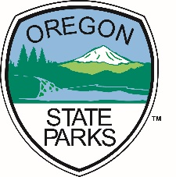
Explore the Fort Stevens
Tsunami Quest!
Quests are fun learning adventures!
Follow clues and hints to discover the natural, cultural, and historical treasures of Fort Stevens. Suitable for groups of all ages, this self-guided Quest lets you explore parks, trails, and other outdoor spaces in new ways—at your own pace.
Pick up a Fort Stevens Quest Packet at the Ranger Station or Visitor Center.
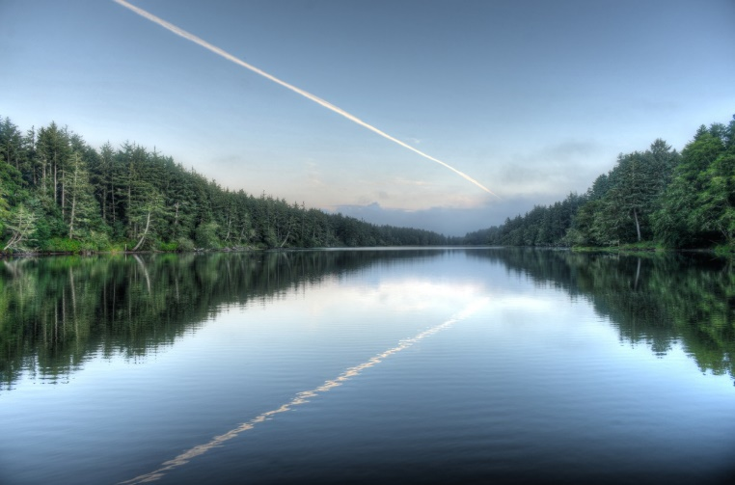
The Fort Stevens Tsunami Quest begins at the Information Booth near the 4-way stop sign in the campground.

Fort Stevens Tsunami Quest
To complete this quest, follow the clues to collect letters. At the end, use them to spell out the location of the hidden quest box.
Your adventure will take you through the campground, lake, and trails of Fort Stevens. Along the way, you’ll learn fun facts about the park and discover important tsunami awareness information.
The route is about 1 mile long, on both paved and natural-surface trails, and usually takes around 1 hour to complete.
Start your quest at the Information Booth near the 4-way stop sign in the campground.

Let’s Begin!
A tsunami is a large wave
caused by disturbance in the ocean.
An underwater earthquake
can set a tsunami in motion.

If the ground starts to shake,
that’s your clue to know
to get up to high ground;
QUICKLY…not slow.
Local vs. Distant Tsunamis
Local Tsunami – A big earthquake just off the Oregon Coast can create a tsunami that reaches land in minutes, flooding low-lying areas. Local tsunamis strike roughly every 300–500 years. The last local tsunami in Oregon occurred on January 27, 1700. With a local tsunami, the earthquake itself is the warning, so it’s crucial to get to high ground immediately.
Distant Tsunami – A distant tsunami comes from a far-away source, usually more than 1,000 km away or over 3 hours travel time from its origin. Distant tsunami waves are smaller, and there is usually enough time for park staff and emergency officials to warn people and get them off the beach safely.
At the 4-way intersection,
what signs do you see?
They tell you where to go
To escape a tsunami.

The blue and white signs
point East toward high ground.
The aptly named “Ridge Road”
Is where elevation can be found.

Today, on this Quest.
We won’t go that direction.
Instead, we’ll look for other spots
That could provide protection.

DID YOU KNOW?
A series of high ridges and valleys runs north–south along the coast here in Clatsop County. These were formed long ago when the area was covered with sand dunes.
Many areas in Fort Stevens State Park are safe from tsunami flooding. Let’s see if we can find some of these high places!
To begin this Quest,
Go with your family, or go alone.
Start out by heading West
Go to the path near four stones.

Walk South on the path.
then up ahead on your right
go across a footbridge
that is just out of sight.

Down this path,
head right at K15.
Just up ahead
a map will be seen.

Nice job, you found it!
We hope you’re having fun.
The first letter of the name of the bay
goes in square #1.

When campers arrive here,
the first thing they should do
is orient themselves.
Just like you.

Go between the trees and past the chain.
Do you feel the path start to rise?
To the end of this trail you will remain.
That’s where high ground lies.

When you get near the road
the ground here is high.
If a tsunami came now
you would stay dry*.
*unless it’s raining, of course.
Look both ways.
It's ok to go slow.
Across the road
is the way you need to go.

Just across the road
you will see a sign.
The first letter of the lake’s name
goes in box #9.
Coffenbury Lake gets its name from Clatsop County’s first judge, George Coffenbury. He owned a dairy farm in this area and was known for having some of the finest vegetable gardens on the Clatsop Plains.
During World War II, a Japanese submarine fired on Fort Stevens, and one of the shells is believed to have landed in Coffenbury Lake! Fortunately, the submarine missed its target, leaving only craters in the sand and wetlands around the area.
Let’s continue on
and find more high ground.
But first that means
we’ll have to walk back down.

Head down the trail
and go past the ferns.
When you get to the fork,
to the right you will turn.

You’re in a lower spot now
compared to where you just were.
Lower spots are where
lakes tend to occur.

Go along the lake’s edge;
veer away from the street.
Look for a sign near the parking lot.
It’s kind of discreet.

The double vowel on the sign
goes in the # 11 square.
Did you figure it out?
Write the vowel in there.

How do you spell “11”?
That’s right, you did great!
Put the first letter of the word
in square number 8.
Up ahead on your left
Find the sign for how fast boats can go
The middle letter below the 10 is what you
want to know
The letter you see goes in box #3

No need to hurry.
You don’t have to be first.
Go to the fountain where you can quench your thirst.

There’s a hidden letter
on the fountain’s rocks.
That letter goes in the #12 box.

Head down the path
toward a sign that is white.
Continue on the bike path.
Follow it and go right.

Make sure you wear your helmet
when you ride your bike.
If you fall and hit your head,
it could save your life.

The first vowel of what you ride goes in box # 7.

Life jackets… helmets…
Staying safe keeps things fun.
Being prepared can pay off
in the long run.

Near the tunnel you'll see a CAUTION sign.
It says to go slow.
In square #4 the last letter on the sign should go.

Go down through the tunnel,
and watch out for bikers.
Sometimes they don’t see
people who are hikers.
On one side of the tunnel
How many yellow lines do you see?
“M” goes in that number’s box
most perfectly.

Is the tunnel low ground, or high?
That’s right, we’re still quite low.
But high ground is ahead.
Up the hill we go!

We want you to be safe.
Safety is important for you.
The first letter of it
goes in box #2

Go up the hill to a bench.
Take a break, have a seat.
Here you can relax
and rest your tired feet.

Check the tsunami map.
Find your position.
Have you found high ground again?
Have you achieved your mission?
Can you find your location on this map? Are you in a safe area or not? Remember, during a tsunami, the most important thing is to get to high ground.
While you’re exploring, try to spot the nearest high points—it’s always good to know where to go if you are ever in a tsunami zone
If, while sitting on this bench,
you felt the earth shake and sway,
you could remain here at high ground
to stay out of a tsunami’s way.

After a quake,
once you’re at a safe height
it’s important to STAY there for hours
(even overnight).
DID YOU KNOW?
After the first tsunami wave hits the shore, more big waves can follow for several hours. It can take up to 24 hours before it is safe to go back downhill.

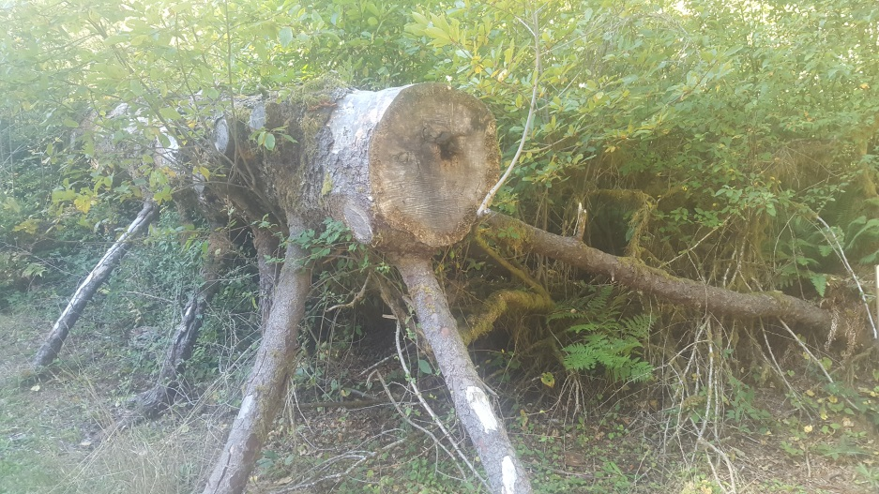
The middle initial for whom
the bench is named is the letter that goes in the #5 frame.

Look for this log
that came down on a whim.
The letter for box #10
is on the right near a limb.

A tsunami can be
quite a danger.
If you don’t believe me, go ask a ranger.

If you are in a place
where evacuation signs are found,
pay attention to the arrows;
they lead to high ground.

Go down the hill.
A crosswalk you will see.
You are almost done,
Yahoo! Yippee!

Go through the cross walk,
to the sign facing the lot.
You are very close
to the treasure you have sought.

Look closely at the map.
Your location it will show.
In case of a tsunami,
find all the places you could go.

Look low and with discretion to
retrieve your buried treasure.
Sign your name and stamp your book.
It has been a pleasure!
If a tsunami were to occur, would you know where to go? Study the map and find the nearest high ground. Remember, after an earthquake, roads may be blocked or obstacles could make evacuation harder. Knowing where to go could save your life!

7

6
5
4
12
2

1

8

5
10
6
5
3
4
11
7
1
9
5
12

Congratulation! You completed the tsunami quest! If you enjoyed the
Tsunami quest, be sure to check out the History Quest in the Fort Stevens
Historic Area!
Stamp

