GIVING TO OREGON SEA GRANT
Thank you for your support!

CONTACT INFORMATION
Name(s) Address City/State/Zip

Email Phone

GIFT INFORMATION
Amount of gift $ I would like to make a recurring gift of $ per: month/ quarter/ year (please circle one)
#of payments starting date This gift is in honor  in memory 
Person being recognized:

AREA(S) OF SUPPORT
General Support
 Scholarships
Marine Science Education
 Hatfield Visitor Center

METHOD OF GIVING
Check make payable to: OSU Foundation (please note in memo line “Oregon Sea Grant gift”) Debit/credit card:
Card no: Exp. Date: Online: seagrant.oregonstate.edu/make-gift
For gift of stocks call 800-354-7281.

MATCHING GIFTS
Your employer may double or triple your gift. If you have questions please visit osufoundation.org/ matchinggifts.

PLEASE SEND ME INFORMATION ABOUT
Including Oregon Sea Grant in my will/trust or
as a beneficiary of my retirement account.
Making a gift that returns a lifetime income
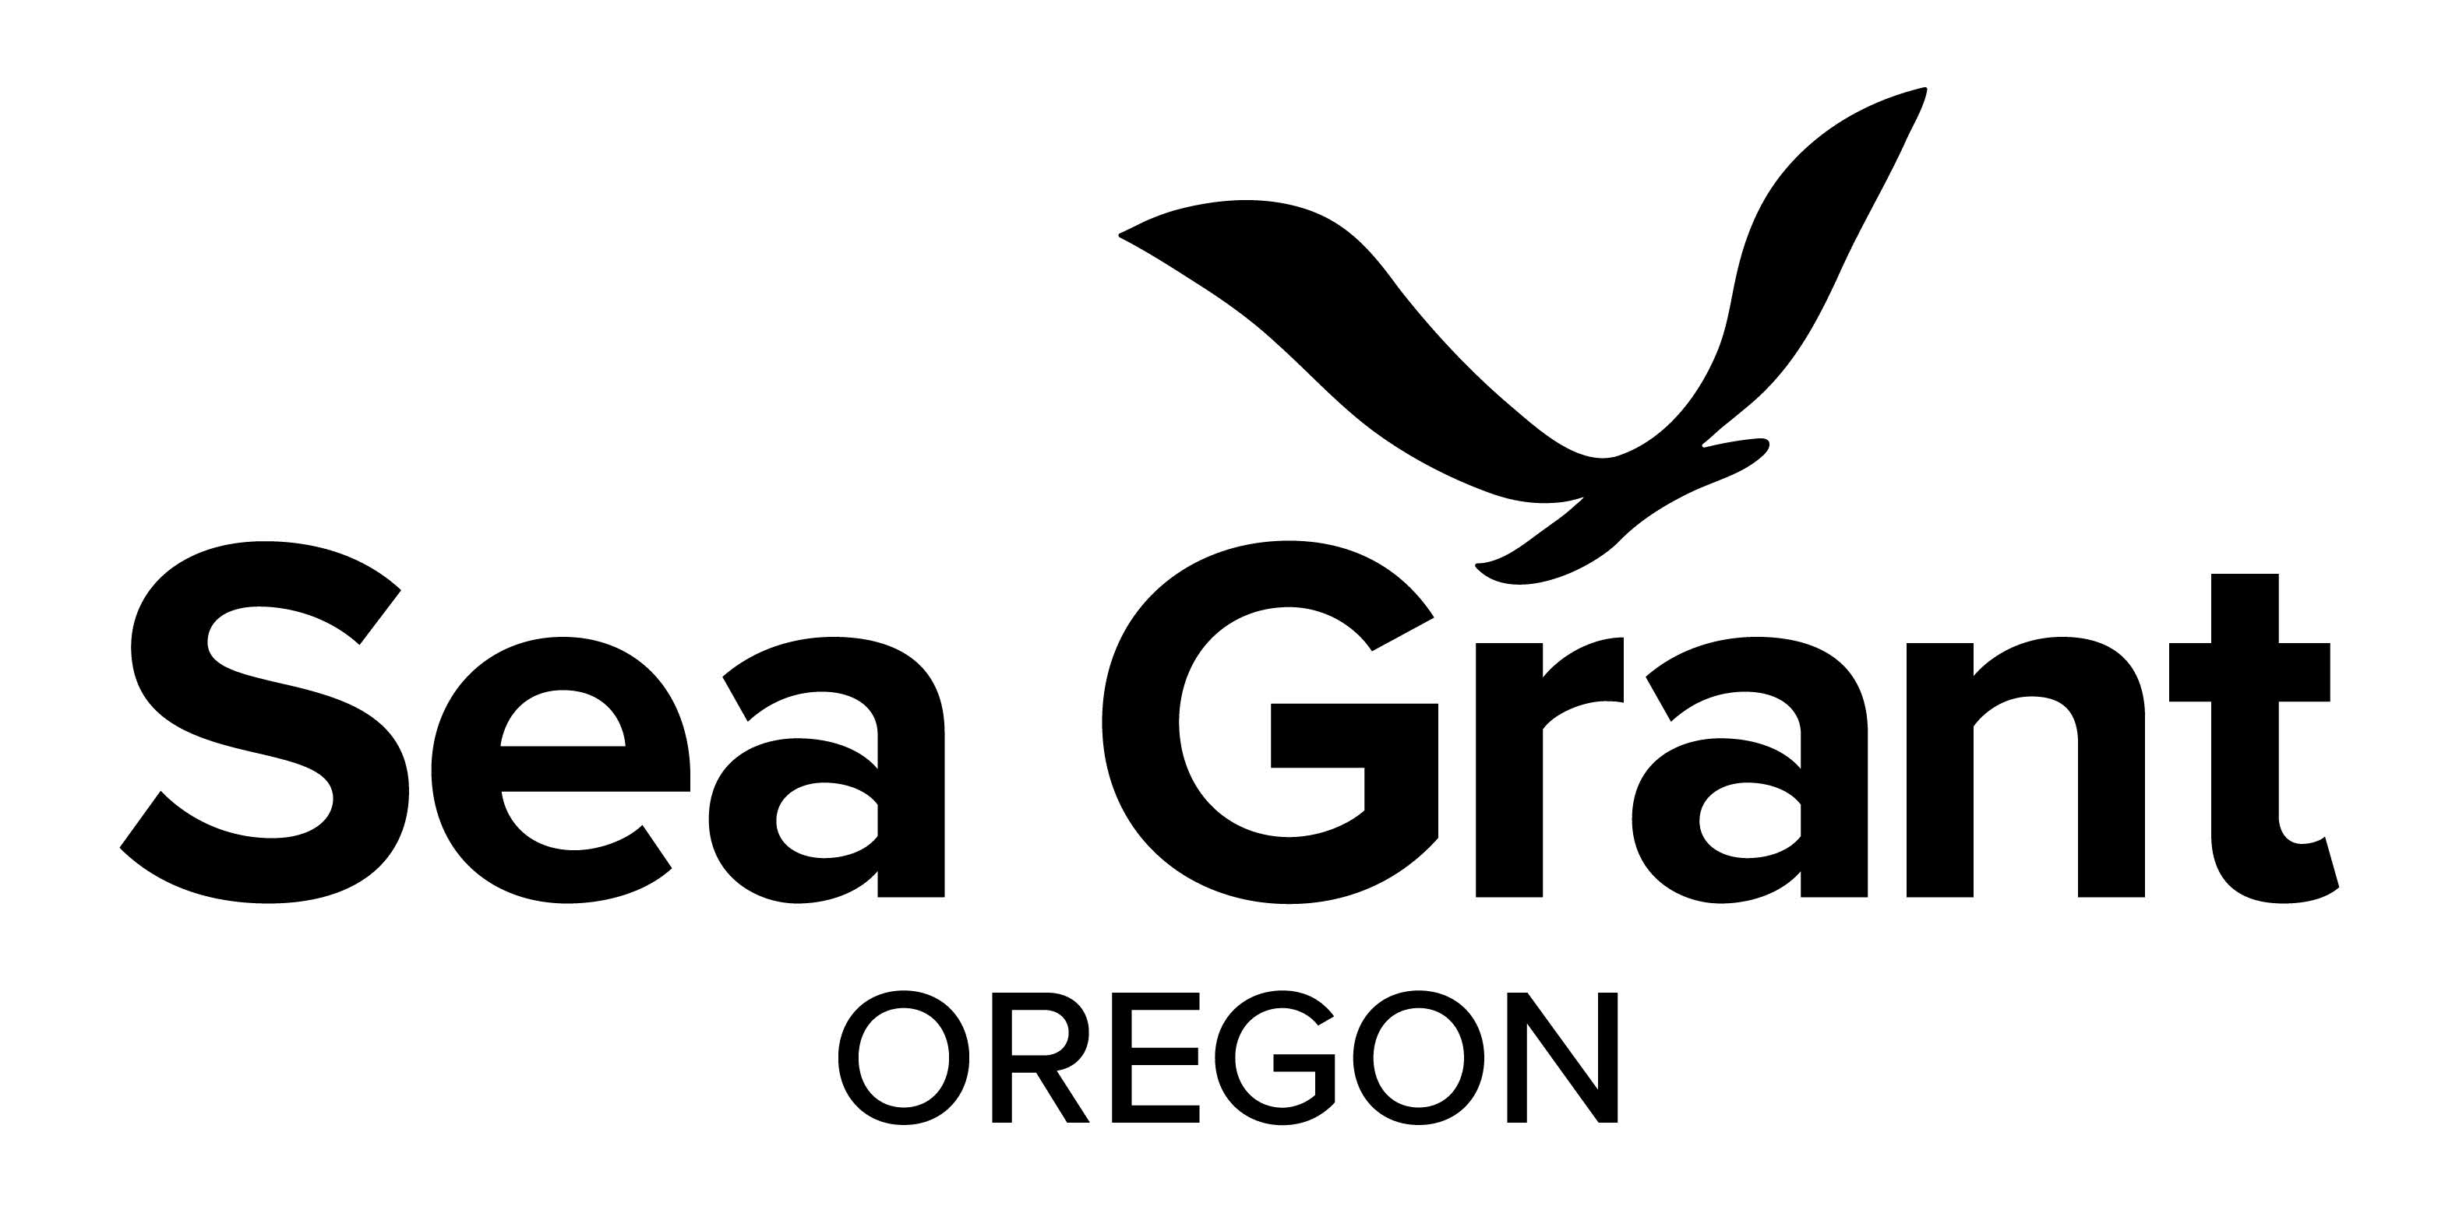

The OSU Foundation is a fully qualified nonprofit charitable organization. Your contribution may be tax deductible.


Return this form to:
OSU Foundation
4238 SW Research Way Corvallis, OR 97333-1068

Questions? Want to make a gift by phone or online? Call: 541-737-4218 or 1-800-354-7281
Email: OSUFoundation@osufoundation.org
Visit: seagrant.oregonstate.edu/make-gift osufoundation.org

