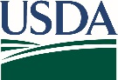
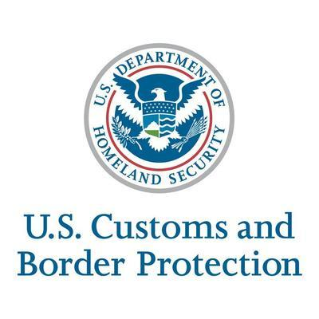

Dear International or Study Abroad Program Director, Manager, Coordinator, or Counselor.:
The language below is provided to assist you in sharing information about the Don’t Pack a Pest Campaign with your students. Please feel free to copy/paste the information below into your website, email, or newsletter.
--------------------------------------------------
Packing Tips:
Be aware that the United States has laws that prohibit or restrict certain foods, plants, animals, and other agricultural items from other countries because they could be carrying damaging pests and diseases.
Please do not pack fresh fruits and vegetables, herbs, meats, dairy, wooded handicrafts, plants, seeds, soils, natural medicines, or other agricultural items.
You can find more information about what is prohibited at this website: https://www.dontpackapest.com/Travel-Guidelines.
Remember, many items you may wish to bring are already available at stores in the United States.
Finally, always DECLARE and tell a customs official if you have any food, plants, and agricultural items when you arrive to the United states. You won’t be penalized if you declare, but not declaring can result in a penalty of up to $1000.
Here are some resources for more information:
DPAP Brochure for Student Travelers. This quad fold brochure highlights some of the risks posed by invasive pests and provides examples of generally prohibited items. Also available as a pdf.
Powerpoint Presentation. For student orientations or to share with administrators
Video. A one-minute video starring U.S. Customs and Border Protection agricultural produce detection dog, Linus. Linus informs the traveling public about prohibited items and declaring agricultural items.
Don't Pack a Pest.com website and resources including guidelines on what is restricted
--------------------------------------------------------------------------
For more information about the Don’t Pack a Pest for Student Travelers program, please contact
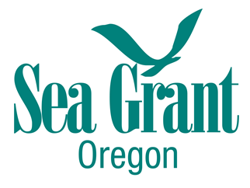
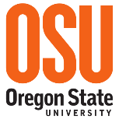
Tania Siemens
Don’t Pack a Pest for Academic Travelers Coordinator
Oregon Sea Grant
Oregon State University
tania.siemens@oregonsate.edu 541-914-0701.
http://bit.ly/Dont-Pack-Pest-Academic-Travelers

