Tsunami Marine Debris: Key Aquatic Species Watch Table for Tsnuami Debris Bioblitz Lesson from Oregon Sea Grant
Instructions: 1) Conduct a “BioBlitz” by quickly rotating (1 minute each station) through the stations and answering the “BioBlitz” questions (Column 1). Then you will be assigned one species to research more thoroughly. On the separate debrief worksheet, answer the questions for your species and prepare to present them to the class (2 minute presentation). As others present, record notes on the other species on this data sheet.
SPECIES | BIO BLITZ | DEBRIEF
 | COMMON NAME/  ID CHARACTERISTIC | PELAGIC/NON PELAGIC? | ROLE IN FOOD WEB | KNOWN INVADER IN PACIFIC NORTHWEST? | WHAT IMPACTS DOES IT HAVE ON HABITAT?
G.Hansen
Undaria pinnatifida
HMSC
Lepas anatifera
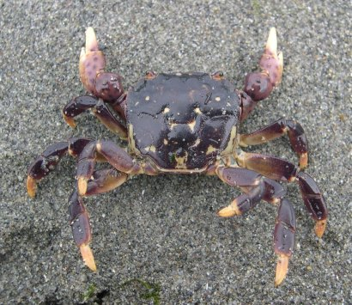
MJ. Adams
Hemigrapsus nudus

Tsunami Marine Debris: Key Aquatic Species Watch Table
SPECIES | BIO BLITZ | DEBRIEF
 | COMMON NAME/  ID CHARACTERISTIC | PELAGIC/NON PELAGIC? | ROLE IN FOOD WEB | KNOWN INVADER IN PACIFIC NORTHWEST? | WHAT IMPACTS DOES IT HAVE ON HABITAT?
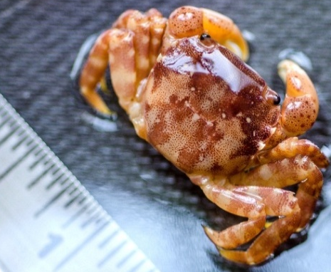
P.Kight
Hemigrapsus sanguineus
OSU-HMSC
Asterias amurensis
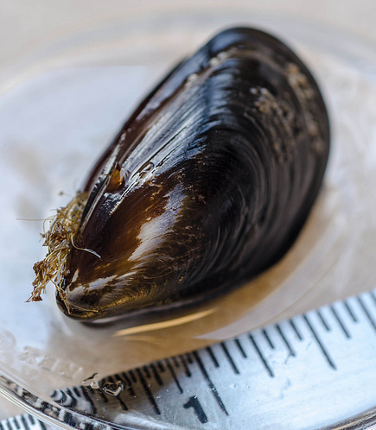
P.Kight
Mytilus galloprovincialis

