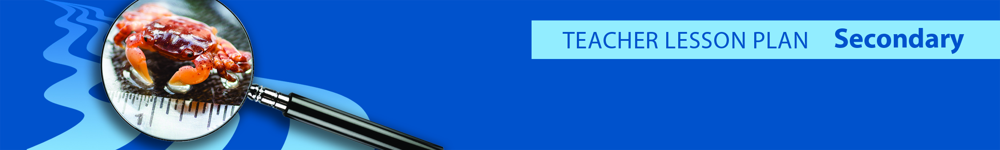
Introduction
Tsunami Debris Species Risk: A Bio Blitz!

There are 2 parts to this fun lesson: 1) Students will view pictures and watch videos showing tsunamis and marine debris, and then use scientific models as a tool to evaluate the many kinds of risk tsunami marine debris poses. 2) Students explore the risk posed by live organisms that have colonized the tsunami marine debris. Inquiries on introduction and spread of invasive species are one important risk we are highlighting as a lesson plan activity.

Students will participate in a BioBlitz by finding, observing, recording and researching characteristics of species that could be found on marine debris. Based on the characteristics, student will evaluate the risk that that species found on marine debris could become invasive, then develop a set of possible solutions (what should we do?). They will debrief to the class their findings.
Grade: 4-12 (adaptable for all grade levels)

Length: 40-60 min

Subjects: invasive species, biology, ecology, environmental sciences, social sciences

Topics: trophic levels, food webs, natural selection, and evolution

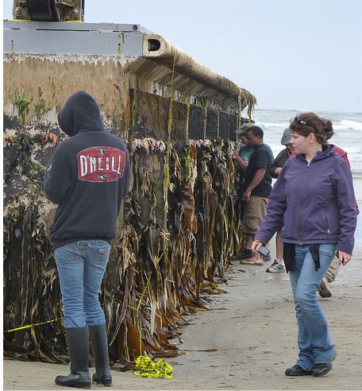
People examine a Japanese dock washed up on Oregon’s Agate beach.

Learning Objectives
- Students learn that scientific models are used to critically evaluate information and determine the risk to their safety.
- Students learn to evaluate solutions based on risk and determine the best action they can take as an individual or as a community leader.
- Students observe potentially invasive species (specimens) associated with the tsunami marine debris and record their findings in visual, verbal and written mediums.
- Students understand the difference between native, non-native and invasive
- Learn research skills to further identify and learn about the species
- Students evaluate the possible role potential risk this species has can have in a food web, ecosystem, human activities and the economy.
- Share information and research to classmates
Background
The March 11, 2011 tsunami off the coast of Japan sent about 5 million of tons of debris into the ocean, of which about 30% (1.5 million tons) are estimated to be currently circulating in the currents of the Pacific Ocean. On June, 2012, the first of several large 188 ton concrete and steel docks washed out by the tsunami from a fishing port in Misawa, Japan, beached onto the coast of the Pacific Northwest. Driven by currents and winds for over 5000 miles, one of the docks landed June 5, 2012 onto Agate Beach, Oregon, carrying with it over 100 living marine species of nearshore, Japanese origin including species known to be invasive. In December 2012, another of the Misawa, Japan docks beached onto Olympic National Park on the Washington coast carrying over 60 species.

Invasive species are organisms that are introduced from somewhere else and quickly dominate an ecosystem. They cause problems for other plants, animals, and people. Invasive species often have physical traits that enable them to reproduce and spread rapidly and outcompete native species for resources. Once they become established, invasive species (especially aquatic species) are extremely difficult to eradicate without causing collateral harm to other

The open ocean is a low-productivity environment in which nearshore species are unlikely to survive for extended periods. The arrival of nearshore species from Japan after at least 15 months in the open ocean provides insight on invasive species pathways driven by natural disasters in the modern era. This phenomenon (e.g. large man-made debris serving as rafts for living near-shore species drifting across the Pacific on ocean currents) is becoming more common. Compared to the 1800s/early1900s, the modern era has created an extensive amount of marine infrastructure. Thus, natural disasters that move pieces of man-made-marine infrastructure are a new dispersal pathway to consider. These marine structures provide multiple substrates and microhabitats for a wide array of biofouling species which include diverse organism types, sizes, and life history stages of the organisms.
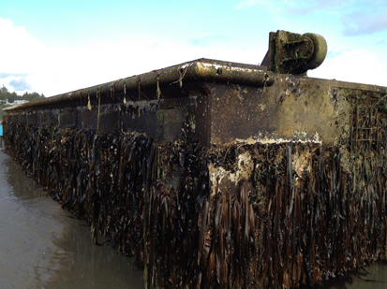
188 ton dock of steel, concrete and foam washed up onto the Oregon Coast on 6/5/2013 nearly 15 months after being torn loose by the 3/11/2011 Japanese tsunami.

Materials Needed
Available on the CD at the links below
- Copies of JTMD HAZMAT guide from the Japanese Govt.
- Copies of handout “Modeled Movement of the Marine Debris Generated by the March 2011 Japan Tsunami”
- Copies of Debris Species Watch Page
- Copies of BioBlitz student sheets
- Learning resources related to each species available at each station. You can use computers with Internet connection or print resources.
- Computer and projector with tsunami videos loaded and ready to show.

Preparation
- Review the links below to familiarize yourself with invasive species.
- Create BioBlitz Learning Stations spaced around your room. Put photos and learning materials about that species at each station. Use the tsunami invasive species watch page as a reference to create laminated photo cards of the species.

Procedure Part 1: Evaluating Risks

Show students pictures of marine debris and pass out the HAZMAT brochure from Japan. Ask students to brainstorm the risks that this debris poses to people and the environment. Tell the students that the risks can be chemical (pollutants), physical (navigational hazards) or biological/ecological (direct ingestion and invasive species. Ask students how we can best prepare for these risks?

One way to be prepared is to know when to expect the debris to arrive. Scientist use models to help them predict how the world is going to work and solve problems. Show the hand-out: “Modeled Movement of the Marine Debris Generated by the March 2011 Japan Tsunami”. Key features to note are that the debris travels in a clockwise pattern and that that different size and shapes of debris arrive at different times and places. Ask the students why? The differences in when and where the debris arrives, relates to factors such as ocean currents, wind, the size of the debris, and how submersed the debris is. Scientist use mathematical formulas (algorithms) that help us predict when and where debris will arrive based on these factors, or model parameters.
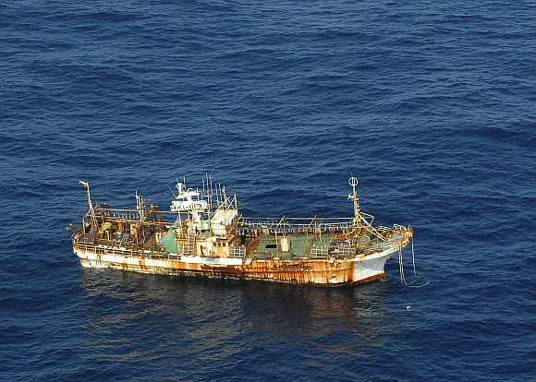
Tsunami driven derelict Japanese trawler off Alaska. USCG

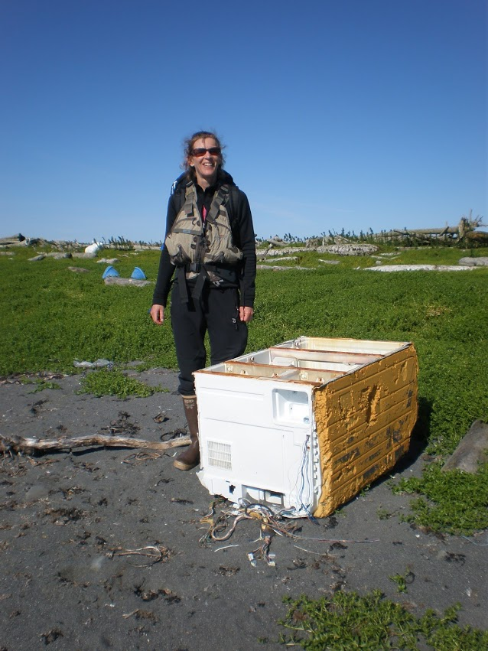
Refrigerator washed up on island in Alaska. Credit Jean Wan Lee

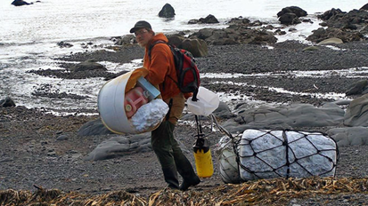
Japanese marine debris found near Seward, Alaska. What items do you see? What hazards might they pose? Note the sprayer, gas jug, foam, lines

Procedure Part 2: Bio Blitz!

Pass out the student “Bio Blitz” sheet and explain to the student that one possible risk associated with marine debris is live organisms that were transported by the debris. Students will evaluate a list of six species that could be found on tsunami debris and determine whether or not they pose an invasive risk.

Divide students into teams (2-3 students per team) and have them conduct a “BioBlitz” by quickly rotating through the species learning stations. (1 minute each station –this simulates a field search) and answering ONLY the “BioBlitz” questions (Column 1) on the worksheet.

Then assign each group to one species to research more thoroughly. Pass out the “Debrief” worksheet. Students work in teams at their species station
to answer the questions and prepare to present a 2 minute presentation on that species. As other groups present, the rest of the class will complete the rest of the columns on the other species on their BioBlitz data sheet.

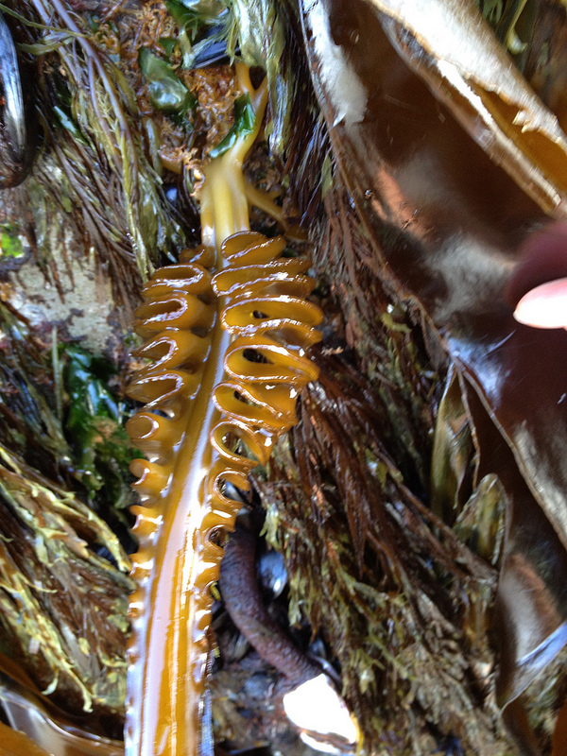
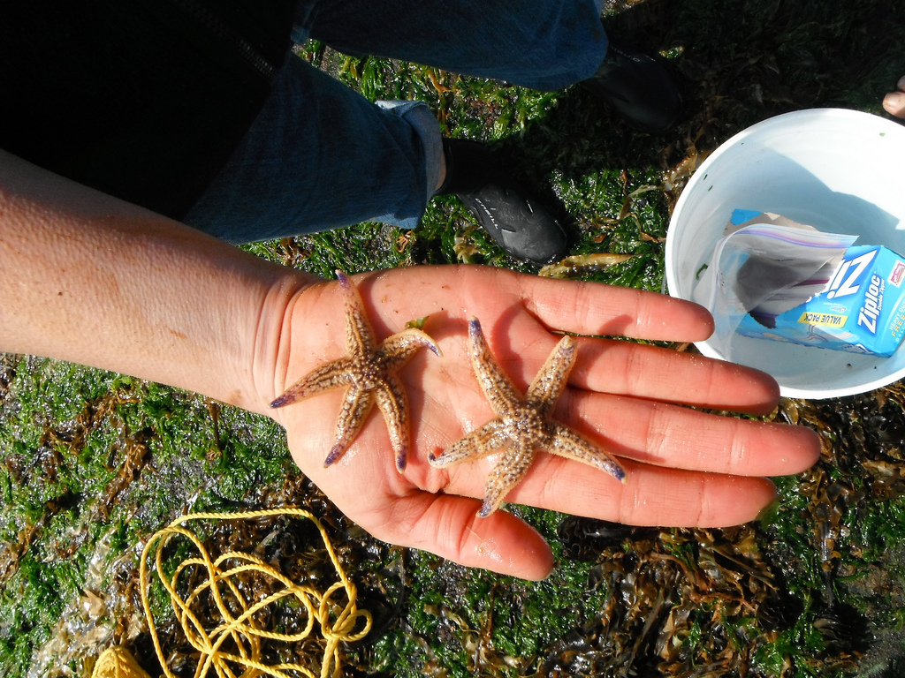
Marine organisms found on Japanese marine tsunami debris dock that beached onto Agate Beach, OR 6/5/2012. Credit OSU Hatfield Marine Sciences Center
Vocabulary Words
Abiotic: non-living

BioBlitz: is an intense period of biological surveying to record living species within a designated area. Typically led by scientists with, naturalists. BioBlitzes are often used to promote public interested in biodiversity.

Biofouling: (the attached and associated free‐living organisms found on marine structures),

Biological Control: the control of destructive organisms by the use of other organisms, such as the natural predators of the pests

Biotic: Of or having to do with life or living organisms

Pelagic: living or occurring in the open ocean

Invasive species: Non-native species disrupting and replacing native species

Native species: species that normally lives and thrives in a particular ecosystem. This can include any species that developed with the surrounding habitat, and can be assisted by or affected by a new species

Non-Native species: species living outside captivity that did not historically occur in a particular area.

Tsunami: a massive sea wave produced especially by submarine earth movement or volcanic eruption

Additional Activities

Aquatic Investigator! Discovering and investigating species on Tsunami Debris. (Goosneck barnicles and European mussels)

Instructions: Walk yourself through the scenario below and answer the questions in bold.

Pretend you are walking/playing/enjoy time on the Oregon Coast and you happen across an old washed up boat completely covered with Goosneck barnicles (or Lepas sp.). You notice some writing on the boat that appears to be Japanese, so you think this might be debris from the Japanese Tsunami of March 2011. (Watch video of a Lepas discovery herehttp://www.flickr.com/photos/80098236@N07/7354608318/).

What are your initial reactions when you see the Lepas and the feeding tentacles that it projects?

You just learned in your class that one possible risk associated with marine debris is live organisms that were transported by the debris. You are curious, so, you decide to do some investigating!

You look up Lepas Sp. on your smartphone, and learn from a reputable website that Gooseneck (or Lepas sp.) barnacles are pelagic (open ocean) species common to both sides of the Pacific.

Do you think the Goosneck barnacles are an invasive species? Why or why not?

But then you notice that the barnacles are attached on top of a colony of European mussels, which know live in intertidal zones and near shore environments (not the open ocean).

What species likely established first? The Lepas or the European mussels?

Curious again, you look up European mussels on your smart phone and read that they are native to Europe. Why would there be European mussels on tsunami debris from Japan? Do you think the European mussel could be an invasive species? Why?

Looking at a picture of the European mussels, is there anything about the way it looks that might make you think this is an invasive species? Why?

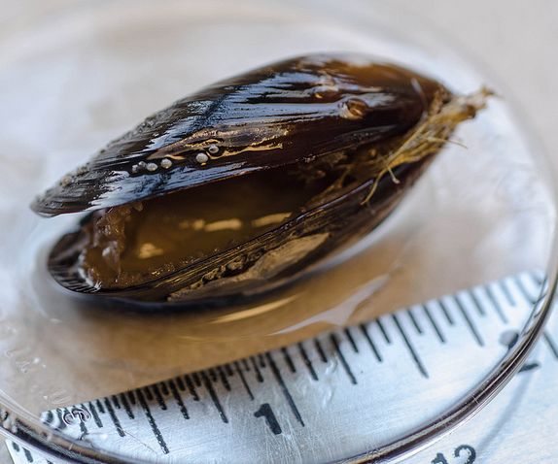
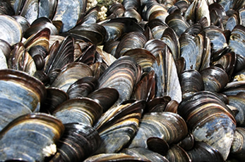
http://www2.plymouth.ac.uk/ Photo: Pat Kight, Oregon Sea Grant

What impact do you think the European mussel would have on Japanese or North America ecosystems?

You decide that it is an invasive species therefore could be harmful to the tidepools that you love to explore! You decide you have to do something. Pick from the list below what actions you would take:

- Take several photos of the organisms found with the marine debris from different distances.
- Send the photos to DisasterDebris@noaa.gov
- Include a size reference in the photos such as a pen, pocketknife, pop can, shoe, etc. (so people see how big the animal or plant is)
- If the item is small, drag the article above the high tide line (keep it out of the ocean) or place it in designated dumpster.
- Bring the marine debris with you home, or move it to another location far from where you found it.

You probably guessed that the one thing you SHOULD NOT do is letter “e” above. The reason is because you might be helping the invasive species spread even more by moving it into a new habitat where it can survive and reproduce. (For example a nearshore estuary or tide pool)

You continue down the beach and spot from a distance another piece of marine debris. You decide to take a guess - What organism do you think you are more likely to find on this new piece of marine debris? Lepas or European mussels? Why?
Tsunami Debris Resources

JTMD HAZMAT guide from the Japanese Govt.
http://marinedebris.noaa.gov/tsunamidebris/pdf/hazmat.pdf

Oregon Geology tsunami clearing house
http://www.oregongeology.org/tsuclearinghouse/

DOGOMI Factsheet/Cascadia Newsletter 2011:“The 2011 Japan earthquake and tsunami: Lessons for the Oregon Coast.” Also available in your CD
http://www.oregongeology.org/tsuclearinghouse/pubs-outreach.htm

Ms. Heidi Keither’s middle school science website on tsunamis. Informative and easy to maneuver.
http://mail.colonial.net/~hkaiter/tsunami.html

NOAA's ERMA GENOME Tsunami Debris model screenshots
http://marinedebris.noaa.gov/tsunamidebris/debris_model.html

Japan's Ministry of Environment- Kyoto University model outputs. See page 4 which depicts surface and below surface movements.
http://www.kantei.go.jp/jp/singi/kaiyou/hyouryuu/pdf/simulation_eng.pdf
An interpretation of the debris predictions
http://iprc.soest.hawaii.edu/news/marine_and_tsunami_debris/2012/12_12_Tsunami_Debris_Update.pdf

Pictures of Japanese Tsunami Marine Debris in Alaska. The is an interactive mapping tool on tsunami debris and potential risks in Alaska to environmental/ecological assets and economic infrastructure. Its very graphic, easy to use via online or desktop ARcGIS plugin, but requires time to learn.
http://dec.alaska.gov/commish/tsunami-debris/
http://www.arcgis.com/explorer/?open=8ac40a055c5349b19e20cf84fdbeacf0

BBC Discover Documentary (45 mins.): Wave of Destruction Alaska tsunami and more. Very informative and shows the excitement of scientists as they inquire and discover.
http://www.bing.com/videos/search?q=lituya+bay+tsunami+video&view=detail&mid=31FF65D7C546C10D379331FF65D7C546C10D3793&first=0&FORM=NVPFVR&qpvt=lituya+bay+tsunami+video

Species found on the Agate Beach and ONP docks. Note that there are 128 verified species of which 117 are live and of Japanese origin vs. pelagic.
http://marinedebris.wa.gov/incidents/ForksDock.html
http://blogs.oregonstate.edu/floatingdock/
Bio Blitz Debrief Resources:

Video of Lepas (Goosneck barnacles) on tsunami debris
http://www.flickr.com/photos/80098236@N07/7354608318/

Smithsonian Environmental Research Center
http://www.serc.si.edu/

National Invasive Species Information Center
http://www.invasivespeciesinfo.gov/

Walla Walla University – Rosario Beach Marine Laboratory
http://www.wallawalla.edu/academics/departments/biology/rosario/inverts/

Global Invasive Species Database
http://www.issg.org/database/welcome/

Other Resources

Statesman Journal Series on Invasive Species in Oregon
Available from: www.InvasiveSpeciesOfOregon.com
The Statesman Journal series on Invasive Species in Oregon features nutria and other species. This Web site has a comprehensive database of invasive species in Oregon, video, photos, and forums to discuss invasive species.

Oregon Public Broadcasting documentary Silent Invasion
Available from: http://www.opb.org/programs/ofg/episodes/view/403
Silent Invasion is an OPB documentary about invasive species in Oregon. The Web site includes many short video segments about specific invasive species or case studies.

The following educational tools are useful for teaching K-12 students about invasive aquatic species.
National Invasive Species Information Center
Available from: http://www.invasivespeciesinfo.gov/aquatics/education.shtml
Nab the Aquatic Invader
Available from: http://www.iisgcp.org/NabInvader/
Menace to the West Curriculum on Aquatic Invasive Species
Available from: http://seagrant.oregonstate.edu/invasive-species

Standards

Reflecting on Science Practices addressed in this lesson

1. Understanding how science works. Exploration and discovery -Asking questions and inquiry (for science) and defining and solving problems (for engineering)
2. Obtaining, evaluating, and communicating information

National Common Core Standards in Life Science Addressed

Core Idea LS1: From Molecules to Organisms: Structures and Processes

LS1.A: Structure and Function By the end of grade 5. Plants and animals have both internal and external structures that serve various functions in growth, survival, behavior, and reproduction.

LS1.C: Organization for Matter and Energy Flow in Organisms- By the end of grade 5. Animals and plants alike generally need to take in air and water, animals must take in food, and plants need light and minerals; anaerobic life, such as bacteria in the gut, functions without air.

Core Idea LS2: Ecosystems: Interactions, Energy, and Dynamics
LS2.A: Interdependent Relationships in Ecosystems - By the end of grade 8 - Growth of organisms and population increases are limited by access to resources. In any ecosystem, organisms and populations with similar requirements for food, water, oxygen, or other resources may compete with each other for limited resources, access to which consequently constrains their growth and reproduction.

LS2.C: Ecosystems Dynamics, Functioning, and Resilience- By the end of grade 8 - Ecosystems are dynamic in nature; their characteristics can vary over time. Disruptions to any physical or biological component of an ecosystem can lead to shifts in all its populations. Biodiversity describes the variety of species found in Earth’s terrestrial and oceanic ecosystems. The completeness or integrity of an ecosystem’s biodiversity is often used as a measure of its health.

Core Idea LS4: Biological Evolution: Unity and Diversity

LS4.D: Biodiversity and Humans -- By the end of grade 8 - Biodiversity is the wide range of existing life forms that have adapted to the variety of conditions on Earth. Changes in biodiversity can influence humans’ resources and services humans rely on.

