Title: Tsunami and Sand Bins – a desk top tsunami and coastal engineering experiment

Grade: 5-12th

Length: 2-4 hours

Subjects/Strands (skills kids are developing): Math, engineering/design, geology/physics

Topics:
- Related to subject: Geology/Earth Science

Introduction:
Tsunamis can affect coastal communities worldwide with sudden inundation, and with little to no warning time whole communities can be washed out to sea. Coastal engineers work to protect coastal communities and their infrastructure from coastal hazards such as tsunamis. At the NEES@Oregon State Tsunami research laboratory engineers use models to help coastal communities. This activity will connect modeling to coastal engineering while having students “play” the role of coastal engineers and attempt to protect a coastal community from a tsunami wave, all in a small under bed sweater box, using Lego houses and common materials.

This activity introduces students to how civil/coastal engineering and design can address problems and enable people to consider choices through cost/benefit analysis to help communities prepare for natural disasters such as tsunamis.

Learning Objectives: Students should understand the engineering design cycle, the destructive nature of tsunamis, simple cost-benefit analysis

Vocabulary words: Inundation, resilience, design cycle, engineering, tsunami

Background:
Tsunamis are a problem worldwide and their destructive powers do not discriminate between developed and developing countries, as the events in Indonesia and Japan have shown us. Oregon is at risk for a large, locally created and destructive tsunami. The Cascadia Subduction zone lies 50 to 100 miles off the Oregon coast, where the Pacific Plate (oceanic plate) meets the Juan de Fuca Plate (continental plate). Every 300 to 500 years this plate boundary “fails” and creates a large earthquake and ensuing tsunami. The last Cascadia Subduction zone tsunami was in 1700. Tsunamis present a large and imminent problem. There is an ever increasing chance of another large event that tsunami events will put the residents and visitors to the Oregon coast at risk.

Engineers help us understand risks and develop solutions:
Engineers work to provide solutions to problems in everyday life. Coastal engineers are constantly working on solutions to help create tsunami resilience within communities. Resilience refers to the community’s ability to respond and recover after a natural disaster. The engineering design process is what research engineers do to try and find solutions for problems. The engineering design process includes the steps of:
- Identify the problem
- Propose/design potential solutions
- Test solutions
- Evaluate solutions – define how well the solution worked and what its cost was (cost benefit analysis)
- Report results
- Refine solution (as necessary)
Not all solutions that would be effective are reasonable or practical. Every solution must be critically evaluated from many perspectives. For example, a large wall might stop a tsunami but it would also be expensive, potentially environmentally hazardous, prevent limit to the coast, etc. It is part of engineering analysis to consider all of the aspects of a solution when analyzing its potential.

Engineers use models to study both the hazards caused by tsunamis (for example large shipping containers hitting buildings) and the solutions. Typically engineers that work at the NEES@Oregon State Tsunami research laboratory combine computer and physical models to better understand the complex nature of tsunamis. Engineers often build and use physical models of structure to generate data to verify computer models so they may apply the models to real world situations.

This lesson draws on both the tsunami hazard models and ways to create resilient communities. Some of the solutions that might work in the sand bins might not be practical for real communities. The practicality of proposed solutions is a good topic of discussion because engineering is a complex field where many aspects of the problem and solution need to be considered.

“Reflecting on Science Practices”
Practices for K-12 Science Classrooms (National Science Standards)
1. Asking questions (for science) and defining problems (for engineering)
2. Developing and using models
3. Planning and carrying out investigations
4. Analyzing and interpreting data
5. Using mathematics, information and computer technology, and computational thinking
6. Constructing explanations (for science) and designing solutions (for engineering)
7. Engaging in argument from evidence
8. Obtaining, evaluating, and communicating information

Materials included: PowerPoint presentation, worksheet masters (note these were developed for 7-12th graders), lesson outline

Materials needed: Per set-up
- Sweater Box (Recommend ~35”x16”x 6”This was developed using the Sterlite model 1960)
- Fine sand,
- ~20 Legos,(to build small houses with)
- 6 2” square pieces of ply wood,
- 10 wood skewers, cut in half, sharp ends cut off
- 10 2” narrow dowels,
- 10 straws,
- Gravel ~1cup,
- Cobbles ~10 3”-4” in diameter or so,
- plywood (or other suitable material) for a paddle to generate waves.
- Note these materials and amounts are suggestions, you may use any materials that might be useful for reinforcing the beaches or securing the houses.

Preparation: Review the included PowerPoint and the lecture notes along with the questions for guided discussion.
Table Top Tsunami Boxes.
- Prepare Table Top Tsunami Box
  - Build small “houses” out of 4-5 Lego bricks
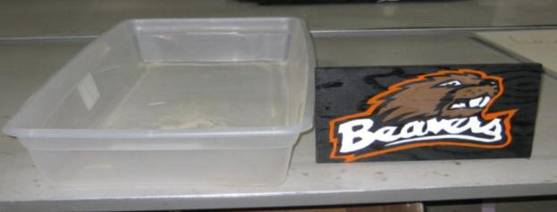
  - Make the wave maker paddle out of plywood or other suitable material cut to the width of the box, and 2-4” taller than the box. (see Figure 1)

Figure 1: "sweater box and wave maker" This is an empty sweater box and the wave maker (painted with the OSU Logo) ready to be setup

  - Fill bottom of the box ¼ high with sand, and then add water so the box is ½ full. Make sure to get the sand wet. Then push the sand to one end to build a beach slope. (see Figure 2).
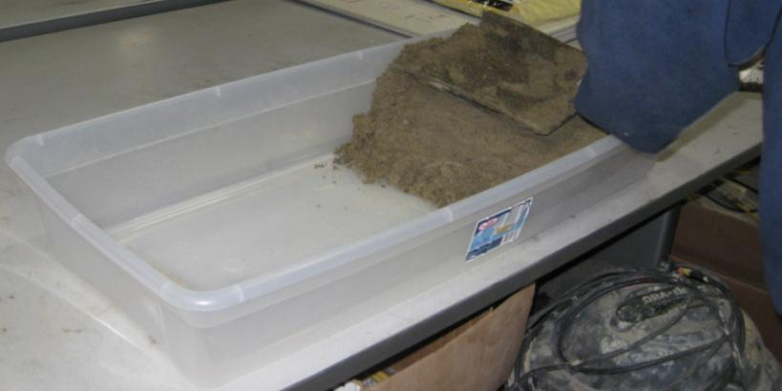
Figure 2: Filling sand bin with sand, note the beach slope

  - Use the wave maker to make waves. Place the wave maker in the box crosswise at the end away from the sand, and then move it all the way down toward the sand in one swift motion to make a tsunami or back and forth to make wind driven waves (see Figure3). It should be noted that “splash” can be considerable and potentially this activity is best outside.

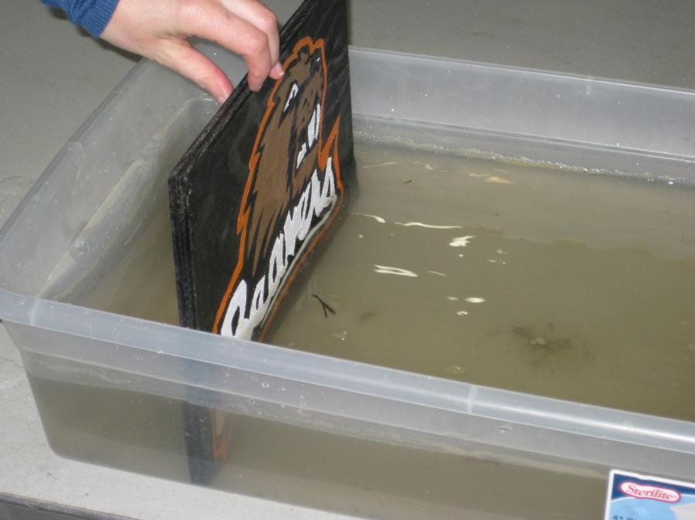
Figure 3: Wave maker ready to make waves. Push it from the end all the way down to the bottom of the box to make a tsunami, smaller “rocking’ motion will make a smaller wave.

Procedure: Note this lesson can be a several day lesson or shortened to a 1-2 hour lesson depending on the amount of time available. The procedure is written for 2-3 hour lesson, with additional items added as ‘optional steps’.

- Have one sand bin set-up and 4-5 houses on the flat part of the beach
- Show students the “Surviving Tsunamis on the Oregon Coast: Engineers think inside the box” PowerPoint sections that they may not have a firm grasp of or that are relevant to the learning goals. (30 minutes)
- Follow up the PowerPoint presentation with a guided discussion reinforcing the tsunami and engineering design cycle content. (15minutes)
- Discuss with students how tsunami is a problem and they will be practicing to be engineers by trying to solve the problem (10 minutes) (Optional have them set the “building” code, or rules for how the beach/houses must be modified. Otherwise the teacher will set the limitations/rules)
- Demonstrate how a tsunami will wash the houses away. (5 minutes) (Optional discussion – modeling discussion – how is the model useful, what are the assumptions)
- Divide the students into teams of four (note: four is not a magic number for lesson but it’s the largest number recommended for the teams – teams are important because all engineers work in teams). (5 minutes)
- Show them the materials they will use to help build a community resilient to the tsunami. (plywood squares, skewers, straws, small gravel, cobbles etc)
- Depending on the skill and maturity of your students, have them set-up the bins or have them prepared. (5-15 minutes)
- Have teams follow the engineering design cycle:
  - Identify the problems that tsunami can cause
  - Propose/design potential solutions to mitigate the problem
  - Test solutions (e.g. build tsunami resistant structures, build structures that can dissipate or re-direct the wave and it’s energy) have faster warning systems and greater accessibility, well-marked and easily accessible escape routes)
  - Evaluate solutions – define how well the solution worked and what its cost was (cost benefit analysis)
  - Report results
  - Refine solution (as necessary)
- Optional step – have students propose a final design for the “city planning committee” (class) or teacher to approve)
- Provide teams a budget by either giving everyone the same materials or putting a price on the materials and giving students a specified amount of funds. (Optional – students could use a spreadsheet program like Excel to track their spending and or they could graph how well each design does verses money spent.)
- Once students have a final design – they need to report their findings. They can use the work sheet attached. (Optional: student groups could report their findings to the class).
- (Optional)If you would like to add a simple math component to this activity you can “charge” for materials. You can do this in one of three ways. Option 1 – Set a limited budget, each group gets $100 and then charge for each item, price items according to how useful they are, for example the plywood squares and cobbles would be most expensive -- $10 apiece, and they skewers and straws would be $3 a piece. Option 2 – Would be to have “unlimited” funds but still charge for materials, and then use final cost as part of the assessment/ discussion. Option 3 would be to give each group a set amount of materials and see how creative each group can be. There is an included worksheet for calculating costs, but this could also be done in excel as additional exercise.

Conclusion and Evaluation: In the end students should understand that engineers use a specific process to develop and design solutions to problems. Students should also understand that engineering problems are complex and there are no quick and easy answers. Students should also understand that the Oregon coast is due for a large and potentially devastating tsunami event.

Resources:
https://nees.org/shakeout
This website lists tsunami and earthquake resources

http://www.tsunami.noaa.gov/
National Oceanographic and Atmospheric Administration Tsunami Website

http://www.ready.gov/tsunamis
This provides information on current tsunami readiness
http://www.oregongeology.org/sub/earthquakes/earthquakehome.htm
Oregon Tsunami and disaster mapping

Standards:

National Common Core Standards in Science and Engineering: (see
Challenges – organized by grade “bands” not grade level.

Ocean Literacy Standards: (relates to Ocean and Great Lakes, and Watersheds that lead into them) Select the following that apply.

* Ocean Literacy Principle #1: The Earth has one big ocean with many features.
* Ocean Literacy Principle #2: The ocean and life in the ocean shape the features of Earth.
* Ocean Literacy Principle #3: The ocean is a major influence on weather and climate.
* Ocean Literacy Principle #4: The ocean makes the Earth habitable.
* Ocean Literacy Principle #5: The ocean supports a great diversity of life and ecosystems.
* Ocean Literacy Principle #6: The ocean and humans are inextricably interconnected.
* Ocean Literacy Principle #7: The ocean is largely unexplored.

NEES is the George E. Brown, Jr. Network for Earthquake Engineering Simulation. For more information visit nees.org

